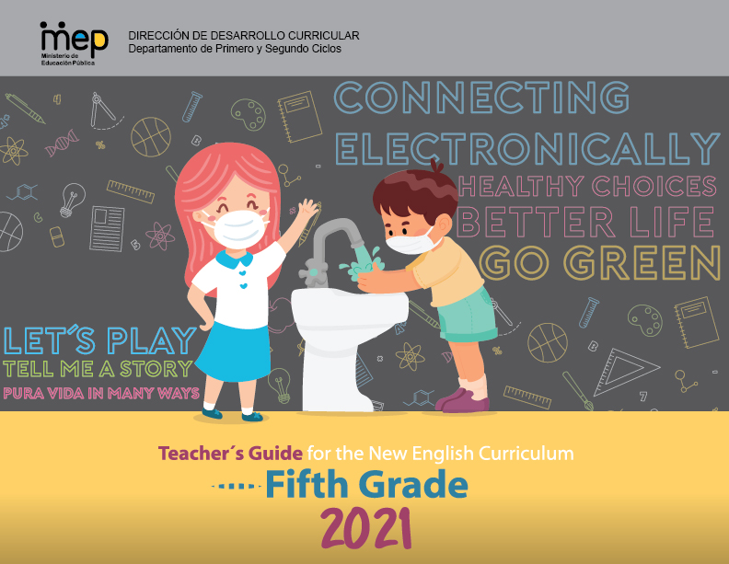

**Presentation**

**Dear teachers**

This is unit 1 of Fifth Grade Teacher´s Guide and have the purpose to provide English teachers of Fifth grade with the guidelines on how to develop effectively the knowledge, skills and abilities set in the new English syllabus. As a result, learners can achieve an expected level of performance in the target language according to the CEFR. We believe that you know your students best and therefore we encourage you **to adapt and contextualized** what you find here so that it responds to the needs and context of your learner. This lesson plan includes in the first page of the planning template, the four dimensions of the new Curricular Policy, “To Educate for a New Citizenship”. The ones mostly emphasized in the unit are identified with an X. These dimensions are embedded and developed in the learning experiences provided. This unit will be completed within a timeline of six weeks.

The unit includes all the steps that should be followed in the pedagogical mediation which are:

A. **Assessment Strategies and Evidences of Learning:** Each goal has a specific assessment indicator for each linguistic competence that requires the elaboration of assessment instruments. Sample models of rubrics are provided

B. **Goals:** Each lesson has specific and clear learning goals connected to a domain, scenario, theme and language function.

C. **Pedagogical Mediation/ Didactic Sequence:** subdivided in the following stages;

✓**Pre-Teaching:** (Warm-up, Activation of Prior Knowledge, Modeling, Clarifying)

✓**Pre-task:** Introductory activity for activation of students’ prior knowledge to carry out a specific task connected to a goal. It places emphasis on the linguistic, cognitive resources needed by the leaner.

✓**Task rehearsal:** Class work where students practice the language in a meaningful way for successful task completion.

✓**Task completion:**  A task that learners perform to demonstrate that the goal has been successfully achieved.

✓**Task assessment:** An activity for reinforcement of the goal. It can also be used for self and/or peer assessment and teacher feedback and/ or repair in relation to the achievement of a goal. Evaluation tools to evaluate performance tasks, of what students know and can do.

D. **Time:** Each phase of the didactic sequence includes a suggestion for the time that may be needed.

E. **Integrated Mini Project:** The project is a creative opportunity for students to integrate knowledge, abilities and skills**.**

F. **Reflective Teaching:** Suggestions for you to assess your own progress in teaching the material.

G. **Enduring Understanding Reflection**: Space to record how students grasped new understandings and ideas in connection with the essential question of the unit.

We hope that this effort will help you to customize your teaching in an effective, creative, engaging, and interactive way in response to your students ‘needs. This unit offers a variety of activities for each phase of the lesson plan; the teacher selects those that are appropriate for achieving the learning goals, the context and learners needs, and the numbers of lesson available for teaching English in the school.

|  |  |  |  |  |
| --- | --- | --- | --- | --- |
| **Level 5th Unit 2**  **Scope and Sequence** | | | | |
| |  | | --- | | **Dimensions** | | **1.** **Ways of thinking ( X  )** | | **2. Ways of living in the world  ( X )** | | **3. Ways of relating with others  ( X )** | | **4. Tools for integrating with the world  ( X )** | | | | | |
| **Scenario: Pura Vida in Many Ways** | | | | |
| **Enduring Understanding** | Our occupations, traditions, music, the way we celebrate, the kind of food we eat, and the way we dress make us unique between provinces in Costa Rica. | | | |
| **Essential  Question** | How does the place where we live define us? | | | |
| **Assessment and Goals** | | | | |
| **Week 1** | **Week 2** | **Week 3** | **Week 4** | **Week 5** |
| **Theme**   1. What´s Going on in Town? | **Theme**  2. What Makes your Province Unique? | **Theme**  3. Costa Rica: “No Artificial Ingredients” | **Theme**  4. In & Out Costa Rica |  |
| **Assessment:**  **L1.** Recognizes short, clear, and simple instructions and explanations when delivered slowly (e.g., how to dance a particular rhythm or elaborate a craft or typical dish).  **R1.** Recognizes much of what is written in short, simple texts on subjects with which they are familiar and/or in which they are interested.  **R.PA.1.** Distinguishes phonemes for inflectional endings (-ing, -ed and –s).  **SP.1.** Expresses short advices and recommendations  **Goals:**  **L1.** understand short, clear, and simple instructions and explanations when delivered slowly (e.g., how to create a mask or handcraft).  **R.1.** understand much of what is written in short, simple texts on subjects with which they are familiar and/or in which they are interested.  **R.P.A.1.** distinguish phoneme for inflectional endings (-ing, -ed and –s).  **SP.1.** express short advices and recommendations. | **Assessment:**  **L2.** Recognizes the main points in short, simple stories and reports when there is some previous understanding of the topic and if they are read slowly, clearly and possibly repeated.  **R2.** Recognizes and enjoys texts.  **R.PA.1.** Distinguishes phonemes for inflectional endings (-ing, -ed and –s).  **SI.2.** Exchanges information about everyday matters using simple vocabulary (e.g., favorite sports, holidays, music, food).  **Goals:**  **L2.** understand the main points in short, simple stories and reports when there is some previous understanding of the topic and if they are read slowly, clearly and possibly repeated.  **R.2.** comprehend reading, analyze and enjoy texts.  **R.P.A.1.** distinguish phoneme for inflectional endings (-ing, -ed and –s).  **SI.2.** exchange information about everyday matters using simple vocabulary (e.g., favorite sports, names of pets, holiday plans). | **Assessment:**  **L3.** Recognizes the most important points in a straightforward talk or presentation, accompanied with drawings and/or diagrams, provided there was some previous familiarity with the topic.  **R3.** Follows a set of clear-cut instructions, especially if there are pictures or diagrams to illustrate the most important steps  **R.PA.1.** Distinguishes phonemes for inflectional endings (-ing, -ed and –s).  **W1.** Engages in the writing process: pre-drafting, drafting.  **Goals:**  **L3.** understand the most important points in a straightforward talk or presentation, accompanied with drawings and/or diagrams, provided there was some previous familiarity with the topic.  **R.3.** follow a set of clear-cut instructions, especially if there are pictures or diagrams to illustrate the most important steps.  **R.P.A.1.** distinguish phoneme for inflectional endings (-ing, -ed and –s).  **W1.** engage in the writing process: pre-drafting, drafting. | **Assessment:**  **SI.1.**Asks straightforward questions in familiar situations and understands the responses.  **R.PA.1.** Distinguishes phonemes for inflectional endings (-ing, -ed and –s).  **W2.** Uses simple sentences and expressions to describe such things as their surroundings, their holidays, important event and the people around them.  **Goals:**  **SI.1.** ask straightforward questions in familiar situations and understand the responses.  **R.P.A.1.** distinguish phoneme for inflectional endings (-ing, -ed and –s).  **W2.** use simple sentences and expressions to describe such things as their surroundings, their daily activities, and the people around them. | **Assessment**  **Instruments for Process/Product**  **Week 6**  **Suggested Integrated Mini project** |
| **Function**   * Describing my community by traditional: music, occupations, foods, celebrations, dress code | **Function**   * Describing my province traditions, music, occupations, foods, celebrations, dress code and people among other aspects | **Function**   * Describing Costa Rica | **Function**   * Describing travel experiences in or out Costa Rica |
| **Discourse Markers**  First, second, third… | **Discourse Markers**  First, second, third… | **Discourse Markers**  First, second, third… | **Discourse Markers**  First, second, third… |
| **Grammar & Sentence Frames**  Simple Preset Tense   * Popular celebrations/ activities in my community are ________. * In my community we _ (do, eat, wear)… * In my __ (province) people ___ (celebrate, dance, eat, dress).   Adverbs of frequency   * We usually ______. * In our country we sometimes ______: * In my town we __, but in the ___ (city) they ___. | **Grammar &Sentence Frames**    Interrogatives   * What are the most popular activities/celebrations in your community/country?   In Costa Rica we _____.   * What do people do to celebrate ___?   We cook/ dress…  Adjectives   * size: long celebration, small parade. * shape: round, square * colors: white hat, red skirt | **Grammar & Sentence Frames**  Superlative forms  The most beautiful beach of my province is_____.  The best food to eat is ________.  The highest mountain is _______. | **Grammar & Sentence Frames**  Present Perfect   * I have been to the United States three times. * I have lived abroad. * Have you been abroad? |
| **Phonemic Awareness**   * Identifying inflectional endings (e.g., -s, -ed, -ing, etc.) and their functions (i.e., tense, plurality, comparison and parts of speech). * Writing the letters heard in a word in proper order. | **Phonemic Awareness**   * Identifying inflectional endings (e.g., -s, -ed, -ing, etc.) and their functions (i.e., tense, plurality, comparison and parts of speech). * Writing the letters heard in a word in proper order. | **Phonemic Awareness**   * Identifying inflectional endings (e.g., -s, -ed, -ing, etc.) and their functions (i.e., tense, plurality, comparison and parts of speech). * Writing the letters heard in a word in proper order. | **Phonemic Awareness**   * Identifying inflectional endings (e.g., -s, -ed, -ing, etc.) and their functions (i.e., tense, plurality, comparison and parts of speech). * Writing the letters heard in a word in proper order. |
| **Vocabulary**  (**Including but not limited to**)  1**.** What´s going on in town?  Expressions and phrases   * I am new in town. * I would like to go around. What do you recommend me? * What do people to for fun? We go to… * What time is it?   Music   * Folk, salsa, cumbia,   Activities   * Parades, horse shows, pilgrimage, dances   Occupations   * Housewife, cowboy, farmer, | **Vocabulary**  2. What makes your province unique?  Expressions and phrases   * What the most important celebrations in town? * How do you celebrate it?   Holidays & Celebrations   * Saint Patron´s Day, community fair, civic parties, holidays   Typical cuisine   * Rice with chicken, picadillos, soups, grilled beef   Typical dressing   * School uniform, t-shirt and jeans, a hat, boots | **Vocabulary**  3.Costa Rica: “No artificial ingredients**”**  Expressions and phrases   * Where are you from? * What is Costa Rica like? * What are the best places to visit? * Which are the most important celebrations?   Places to go   * Beaches, volcanos, rainforests, wildlife islands.   People to meet   * Indigenous communities ( bribris, cabecares, malekus, Ngobes) * Afro-descendent * Costa Rica is Multicultural and plurilingual | **Vocabulary**  4.In & Out Costa Rica  Expressions and phrases   * Where are you from? * I´m from Costa Rica. * Have you been abroad? Yes, I have been to Mexico. * Have your father been abroad? Yes, he has been to the United States. * How long are you staying in Mexico? For three weeks. * Which places have you visited? * I have been to ...   Countries and Nationalities   * Mexico Mexican * Canada Canadian * Nicaragua Nicaraguan * Panama Panamanian   England English |
| **Psycho-social**   * Respecting other customs and traditions   **Sociocultural**   * Holidays and celebrations   **Idioms/phrases**   * Cat nap (short sleep) I am going to have a cat nap while you are cooking dinner. | **Psycho-social**   * Respecting other customs and traditions   **Sociocultural**   * Holidays and celebrations   **Idioms/phrases**   * Cat nap (short sleep) I am going to have a cat nap while you are cooking dinner. | **Psycho-social**   * Celebrating the differences between cultures   **Sociocultural**   * Loving diversity in Costa Rica and countries around the world   **Idioms/phrases**   * Don´t count your chicken before they hatch (don´t make plans ahead of time) | **Psycho-social**   * Celebrating the differences between cultures   **Sociocultural**   * Appreciating the customs from other cultures   **Idioms/phrases**   * Don´t count your chicken before they hatch (don´t make plans ahead of time) |  |

|  |  |  |  |  |  |  |  |  |  |
| --- | --- | --- | --- | --- | --- | --- | --- | --- | --- |
| **Term: I** | | **Level: Fifth Grade** | | | **Unit:2** | | **Week:1** | | |
| **Domain: Socio-interpersonal** | | | | **Scenario: Pura Vida in Many Ways** | | **Theme:** What´s going on in town? | | | |
| **Enduring Understanding**: Our occupations, traditions, music, the way we celebrate, the kind of food we eat, and the way we dress make us unique between provinces in Costa Rica. | | | | | | | | | |
| **Essential Question:** How does the place where we live define us? | | | | | | | | | |
| |  | | --- | | **Dimensions** | | **1.** **Ways of thinking ( X )** | | **2. Ways of living in the world  ( )** | | **3. Ways of relating with others  ( X )** | | **4. Tools for integrating with the world  ( )** | | | | | | | | | | |
| **Learn to Know** | | | | **Learn to Do** | | **Learn to Be and Live in Community** | | | |
| **Grammar & Sentence Frames**  Simple Preset Tense   * Popular celebrations/ activities in my community are ________. * In my community we _ (do, eat, wear)… * In my __ (province) people ___ (celebrate, dance, eat, dress).   Adverbs of frequency   * We usually ______. * In our country we sometimes ______: * In my town we __, but in the ___ (city) they ___.   **Phonemic Awareness**   * Identifying inflectional ending **ing** and its functions (i.e., tense, comparison and parts of speech).   **Vocabulary**  (**Including but not limited to**)  1**.** What´s going on in town?  Expressions and phrases   * I am new in town. * I would like to go around. What do you recommend me? * What do people to for fun? We go to… * What time is it?   Music   * Folk, salsa, cumbia,   Activities   * Parades, horse shows, pilgrimage, dances   Occupations   * Housewife, cowboy, farmer, | | | | **Function**  Describing my community by traditional: music, occupations, foods, celebrations, dress code  **Discourse Markers**  First, second, third… | | **Psycho-social**   * Respecting other customs and traditions   **Sociocultural**   * Holidays and celebrations   **Idioms/phrases**   * Cat nap (short sleep) I am going to have a cat nap while you are cooking dinner. | | | |
| **Assessment Strategies & Evidences of learning**  (Diagnostic, formative, summative) | **Goals** | | | **Pedagogical Mediation/ Didactic Sequence** | | | | | **Time** |
| Learner…  **L1.** Recognizes short, clear, and simple instructions and explanations when delivered slowly (e.g., how to dance a particular rhythm or elaborate a craft or typical dish).  L1.1. identifies short, clear, and simple instructions and explanations about town activities when delivered slowly (e.g., how to dance a particular rhythm or elaborate a craft or typical dish).  L1.2 recognizes short, clear, and simple instructions and explanations about town activities when delivered slowly.  **R1.** Recognizes much of what is written in short, simple texts on subjects with which they are familiar and/or in which they are interested.  **R.2.2.** gets the gist in short simple texts after first reading.  **R.2.3.** responds to questions completing diagrams and/or maps.  **R.PA.1.** Distinguishes phonemes for inflectional endings (focus on -ing,).  **R.PA.1.1**. recognizes phonemes for inflectional ending (-ing) in sets of words.  **SP.1.** expresses short advices and recommendations.  **SP.1.1.** recognizes different vocabulary, phrases and expressions about giving short advices and recommendations about places to visit in the community.  SP.1.2. gives short advices and recommendations about places to visit in the community and in the country in a real life situation. | Learner can  **L1.**Understand short, clear, and simple instructions and explanations when delivered slowly (e.g., how to create a mask or handcraft).  **R.1.** understand much of what is written in short, simple texts on subjects with which they are familiar and/or in which they are interested.  **R.P.A.1.** distinguish phoneme for inflectional endings (-ing,).  **SP.1.** express short advices and recommendations. | | | * .   **Pre-teaching**  Teacher greets students and introduces Essential Question and goals for the day  **Warm up**  **Connection**   * T starts the class by describing personal favorite free time activities and writes them down on the board as a brainstorm. * Teacher invites students to watch a video and listen to a song, *It is the weekend* <https://www.youtube.com/watch?v=Qp_Ady27kSs> about what children enjoy doing in their town on weekends.   **Activation of Prior Knowledge**  -Teacher asks the students what words related to free time activities they recognized from the song and write them down on the board. After teacher asks: What do you like the most about the video? Do the places mentioned at the song exist in your town? Teacher collects some of the students ‘responses on the board.  -Teacher asks again: What are your favorite free time activities? What do you **usually** do in your town? Which activities or celebrations are popular in your town or country? What do you recommend a new person in town? What do people to for fun?  **Modeling**   * Teacher uses cards to model sentence frames and pronunciation of places and activities around town for having fun. Teacher describes the places and activities using simple present sentences in choral repetition, for example, * What do you usually do in your community to have fun? * I like/love to go to concerts and parades. * Which activities or celebrations are popular in your town or country? In my town, we have Limón´s carnival. // we **always** celebrate with parades, music, theater, and exhibits. * What do you usually eat? We **usually** eat traditional food like rice and beans with chicken or fish. * What do you usually do in your community to have fun? **Sometimes,** we organize soccer championships./ We like to go dancing. We dance merengue, salsa.   **What's in the bag/box?** The teacher fills a bag or a box with cards related with places or activities celebrated in town (e.g. Pet shop, mall, etc.) **(See sample cards in the annex 1)**. Teacher makes one student take out one card of the bag/box. Take out 1 card per student. Finally, each student makes gestures (charades) for his/her classmates to guess the place. The teacher asks: What can you do in that place? I see my favorite movies.  What's in the bag?  **Clarification**  **Clarifying**  To review comprehension of the vocabulary and sentence frames, teacher asks questions about, names of places, activities you can practice, types of celebrations, what people do and eat. For example: what is the name of the place where you watch a movie? Student can answer: it is the movie theater.  **Another question could be: where do you ride your bike: Answer/ I go to the park. More questions: What is the name of one celebration in your town? The Virgen of Los Angeles Day. What do people do?** People walk and pray till they arrive to Cartago´s Basilica.    **Connection**  Pre – task  Teacher shares the goal of the lesson.  **Activity 1. The teacher introduces some new vocabulary students will find in the video. T gives a copy with pictures and words. Students try to match the words and pictures. Then students ask or look for the definitions of the words**  **(See annex 1).**  Sandcastle, fish and ships, ice cream, puppet. Beach, sticks of rock, donkey, pier.  Teacher barinstorm again vocabulary related with places and activities to have fun.  Teacher explians that that they will watch a video about fun activites and celebrations in a different country and town.    **Clarification**  **Task rehearsal**  Students watch and listen to the video for the first time. They will pay attention to the activities that people and children do for fun. They have to take notes.  Students are going to guess the name of the place and the country.  <https://learnenglishteens.britishcouncil.org/uk-now/video-uk/seaside-entertainment> **Till min. 3:04** (Activity B)  Students in pairs share their responses. Students get clarification and feedback from the teacher.  Teacher highlights and repeats some of the expressions watch in the video and explains their meaning. Students repeat and practice. (it can be done in pairs or individually)  **Construction/Application**  **Task completion**  Students watch the video again and pay attention to details answering the following questions:   1. Name three activities you can do at Southend? 2. Name two things you can eat? 3. What makes Southend famous for? 4. What means of transportation can you use to travel in Southend? 5. What types of shows can you enjoy en Southend?   **Collaboration**  Students share responses with a partner. Then, they watch and listen to the video a third time to verify their answers.  The teacher provides feedback. The teacher invites students to write the correct responses on board.  **Collaboration**  **Task assessment**  Based on the video heard, Teacher asks students in small groups to do activity C. Teacher later provides feedback  Finally, the students answer the teacher´s questions related to the video and their real life. (e.g. What ´s going on at the video? Do you like to eat at the fairs? What do you eat? What is your favorite place to go around town? Do you like traditional shows? What shows /festivals/fairs activities/ can you find at your town? What do you do in those activities? What kind of music do you listen to at those events? Do you like it?  Students share responses and self-assess their performance.    ______________________________________________________________  **Connection**  **Pre-task**  -Teacher introduces the goal for the lesson. Teacher introduces a game called **Spin the bottle**. Students sit in a circle with a bottle in the middle. Teacher Spins the bottle. When it stops spinning the student it is pointing to has to answer a question. If the answer is correct then that student can spin the bottle. Students review and practice responding to questions like: (e.g.. What is your favorite place to go around town? Do you like to eat at the fairs? What do you eat? Do you like traditional shows? What shows /festivals/fairs activities/ can you find at your town? What do you do in those activities? What kind of music do you listen to at those events? Do you like it?  -Teacher introduces any new vocabulary or new sentence frames students will encounter in the reading.  Spin the bottle  **Clarification**  **Task rehearsal**   * Before reading, teacher asks students: Do you know any of these towns: Zarcero, Flamingo, Guanacaste, San Isidro del General, Sarchi, Puerto Viejo de Talamanca? What do you know about this places? What are they famous for? Do you want to know more about them? We are going to learn about them in the following text. * First they read it silently. * Then, students chose one of the places of the reading and ask some questions to their classmates. Do you know the place? What activities can you do here? Do you like the food they prepare? Do you like their music? * Finally, they read it chorally with the teacher paying a lot of attention to ing sounds.   **Construction/Application**  **Task completion**  Students read the text for a second time to identify specific information about the text. They answer these questions based on the reading (written and orally). and the teacher checks their answers.   1. Where is Flamingo located? 2. What can you do at Flamingo? 3. Why is Zarcero so famous? 4. Did you visit the place already? 5. Describe what a fiesta civica is in San Isidro del General. 6. Besides Oxcarts what else can you buy in Sarchí? 7. According to the description of Puerto Viejo de Talamanca try to make a drawing of the place. 8. Do you know all these places? 9. What is your favorite place? Why?   10.Write a sentence describing the most important place in your town (e.g. In my town XX the most important place is XX because is very beautiful).  **Collaboration**  **Task assessment**  Students choose one of the places, the one they like the most and create a mind map with the main attraction of the place and the activities you can do there as a form of self-assessment. Students share their work with a partner and with the teacher to get feedback and improve their work.  **Phonemic awareness**  **Connection**  **Pre-task**   * Teacher introduces the goal for the lesson. * Students play charades, “guess my favorite activity¨ they act the different activities that they like (they have to write it down on a paper before). The group can be divided into two. The group who guesses more activities in less time wins.   -Students watch the following videos to understand the use of the -ing ending in words and sentences.  <https://www.youtube.com/watch?v=4DS7pAnV3_g>  <https://www.youtube.com/watch?v=J1UwR97CUYY>  Teacher highlights the main ideas in the video and clarifies the use of –ing.  **Clarification**  **Task-rehearsal**   * Teacher gives the students practice. S/He makes emphasis in pronunciation of **ing** endings. Students have to read and underline all the words that have the – ing ending. * Example:   *Hello! Esteban. What do you like doing on weekends? On weekends, I like to go running with my dog. I like listening to music while running. Sometimes, I stop in the park. There I meet my friends. I like talking with them and playing soccer.*  **Construction/Application**  **Task- completion**  Students play a game where they have to transform the verb in the left column into an action adding -ing. Then they have to say both words in oral form: example   |  |  | | --- | --- | | **Verb** | **-ing** | | **eat** |  | |  |  | | **drink** |  | | **run** |  | | **swim** |  | | **dance** |  | | **play** |  |   Students match words with pictures  **Collaboration**  **Task Assessment**  Students continue practicing forming action verbs words with the –ing ending in pair or groups. Then they create a sentence with each action verb following the model provided.  Add –ing to the verb then create a short sentence   1. Play……………-ing……. Playing   I like playing with my friends.   1. Dance…………-ing……….._______________   ______________________________________     1. Sing………….-ing……….._______________   ______________________________________   1. Run…………..-ing ……….________________   ______________________________________  Students particiapte in self and peer -assessment activites.  **Oral Production**  **Connection**  **Pre-task**   * Teacher introduces the goal for the lesson. Ss watch and compare this video and what they do in their town to have fun. <https://www.youtube.com/watch?v=CZCm9bPDJnI>   -Teacher along with students write the activities they listened to in the video. Then in pairs, students make a list of the activities they do on weekends similar to the people they watched in the video. Then, they are given the prompt:  **What do usually do on weekends?** Teacher provides some examples:  I **usually** go out running with my friends.  I **sometimes** go to the beach.  Where do you recommend me to go this weekend?   * You can go to a concert. * You can go to the stadium. * You can go to the movies.   **Clarification**  **Task-rehearsal**  -Students in pairs or in the house with a family member practice describing what they do during the weekend and recommending places to visit in town.  What do you like to do on weekends? On weekends, I like to …  Where do you recommend me to go this weekend? I recommend you to …  You can….    **Construction/Application**  **Task completion**  -Students have to solve the following situation. A group of friends from Jamaica are going to visit them. They want to know about places to visit and activities to do in town. They also want to know about the things you and your family like to do in their free time. They need the following information:   * Three best places to visit in your town. * The best three places in my town are:…. * The best three activities you can do. * The best three activities you can practice here are…. * The three things you love to do on weekends. * In weekends, I love to…   Student will prepare a short presentation with pictures or a video to respond to his/her friends´ request.   * In your presentation: * Greet your friends * Make a short description of your town * Include the best places you recommend… * Include the best activities that you recommend * Describe what you like to do the most on weekends * Say good bye to them hoping to meet them soon   **Collaboration**  **Task assessment**   * S/he explains what they have to do as a mini project. Students can create a chart, a power point presentation, an e-mail or other creative demonstration talking about what they do on weekends in their town and promoting those places to a foreign friend. They must use simple present tense and questions that they already know from previous lessons.  |  |  |  |  | | --- | --- | --- | --- | | **Level of achievement** | | | | | **Assessment Indicators**  **I can ..** | **Not achieved yet**  ***C:\Users\mcastilloh\Downloads\descarga.jpg*** | **In progress**  ***C:\Users\mcastilloh\Downloads\Grinning-Face-with-Smiling-Eyes.png*** | **Achieved**  ***Resultado de imagen para happy emoji*** | | **L1.1**. identifies short, clear, and simple instructions and explanations about town activities when delivered slowly (e.g., how to dance a particular rhythm or elaborate a craft or typical dish). |  |  |  | | **L.1.2** recognizes short, clear, and simple instructions and explanations about town activities when delivered slowly. |  |  |  | | **R.1.1.** gets the gist in short simple texts about community, places and traditions when reading a text. |  |  |  | | **R.2.1.** recognizes main ideas in short simple texts about community, places and traditions. |  |  |  | | **R.PA.1.1.** recognizes phonemes for inflectional ending (-ing) in sets of words. |  |  |  | | **SP.1.1.** recognizes different vocabulary, phrases and expressions about giving short advices and recommendations about places to visit in the community and in the country. |  |  |  | | **SP.1.2.** gives short advices and recommendations about places to visit in the community and in the country. |  |  |  | | | | | 40 minutes  40 minutes  40 minutes  40 min | |
| **Integrated Mini-Project** | | | | | | | | | **Time** |
| * **Planning** and **creating collaboratively**   a collage and /or a foldable about main attractions and celebrations in my community, province, and country.   * **Rehearsing** the presentation and **reporting it** in oral and written form to the class. * **Participating** in self and co-assessment using technically designed instruments. | | | | | | | | |  |
| **Reflective Teaching** | | | | | | | | | |
| What worked well | | | What didn’t work well | | | How to improve | | | |
| **Enduring Understanding Reflection** | | | | | | | | | |
|  | | | | | | | | | |

**Annexes Week 1**

**Cards for introducing vocabulary and sentence frames**

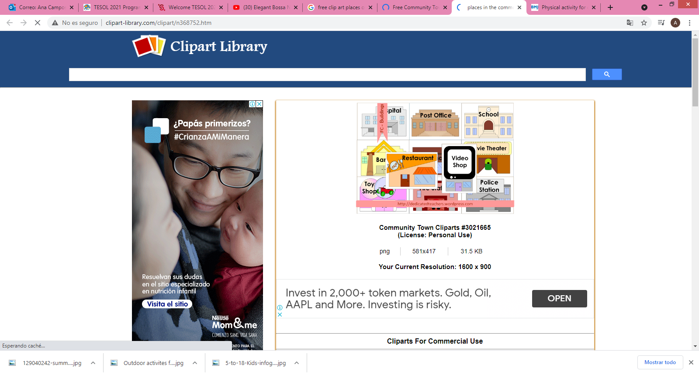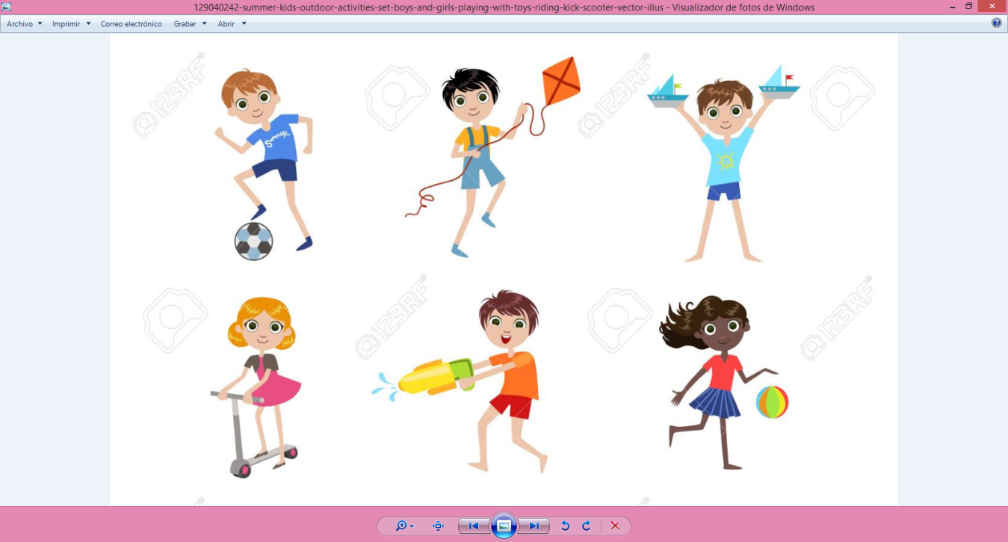

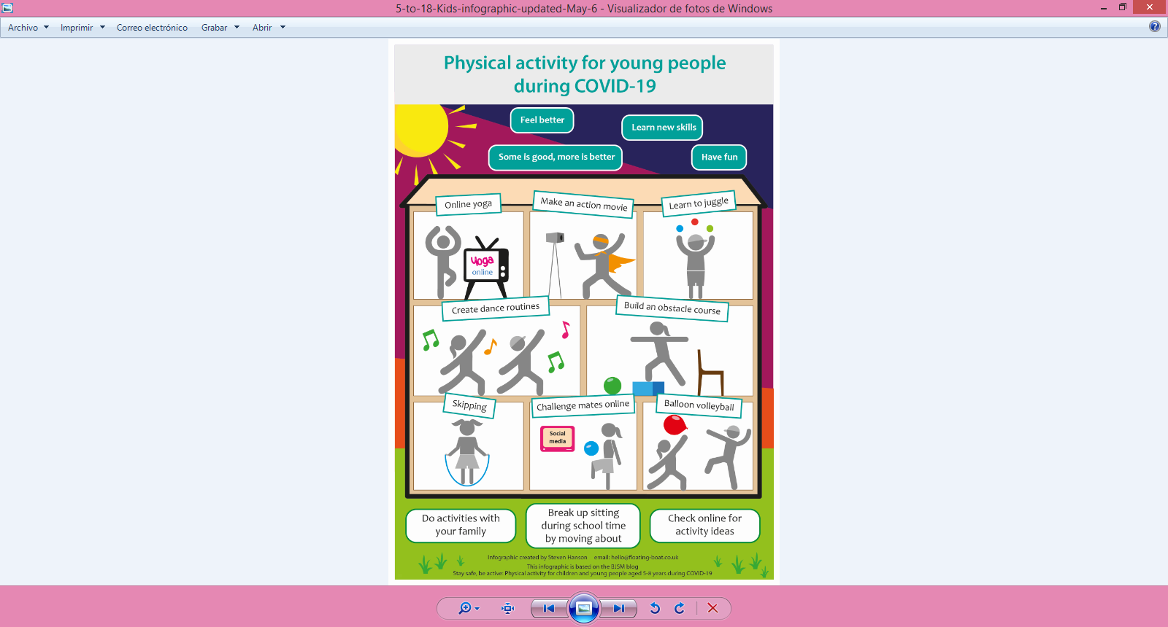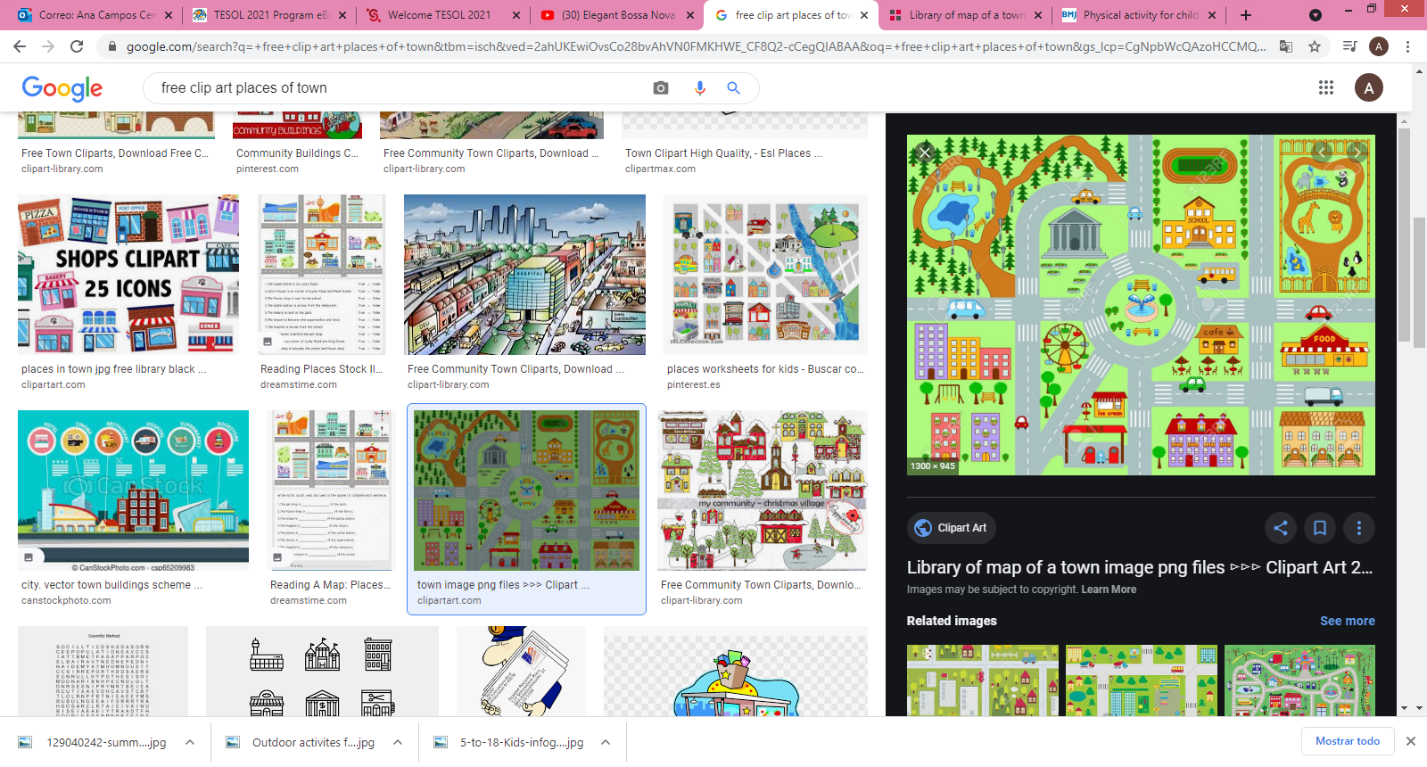

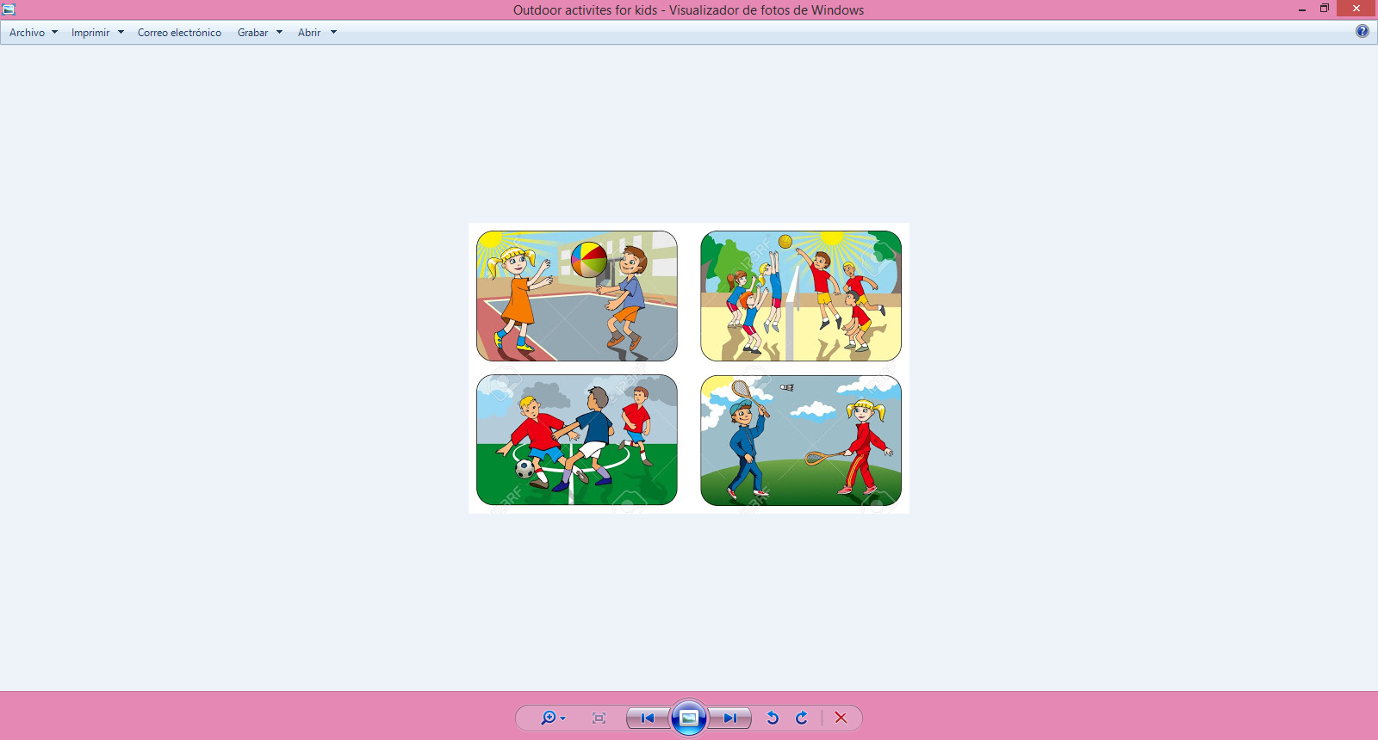

**Activity 1 A before listening** Match the words and pictures. Then ask or look for the definitions.

*Sandcastle, fish and chips, ice cream, puppet. Beach, sticks of rock, donkey, pier.*

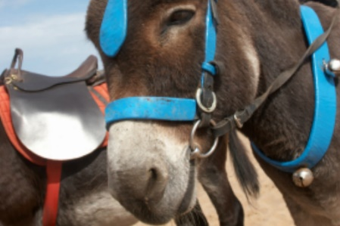 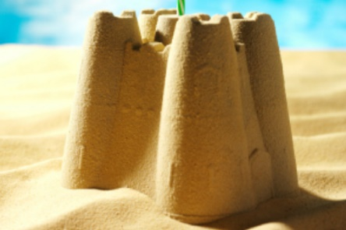 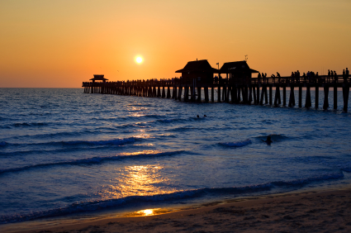



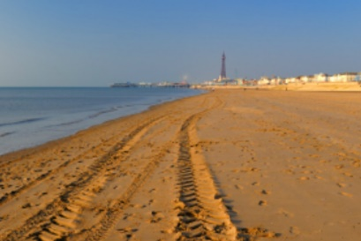 

**Activity B**

Listening activity <https://learnenglishteens.britishcouncil.org/uk-now/video-uk/seaside-entertainment> **till min. 3:04**

**Activity C**

Put the words into the correct groups. Fill this table with the information from the video and your own information. Do it alone or with a partner.

**Donkey/horse rides, eating ice cream, going to the beach, video games, sandcastle building, watching a show, stick of rock, play arcades.**

|  |  |  |
| --- | --- | --- |
| **Activity** | **Video information** | Information of your town |
| **Traditional entertainment** |  |  |
| **Virtual entertainment** |  |  |
| **Traditional food** |  |  |

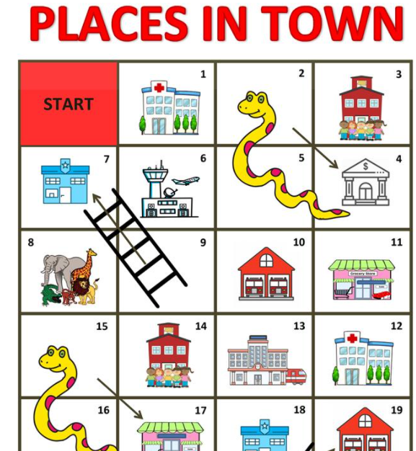

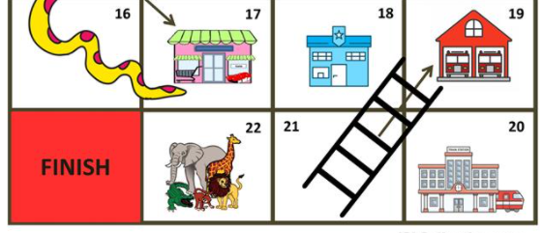

**Activity D**

**Places to visit around towns in Costa Rica**

There are so many places worth visiting in [Costa Rica](http://clkuk.tradedoubler.com/click?p(276458)a(2937610)g(23627528)url(http://www.evaneos-travel.com/costa-rica/)). Most visitors go to places like [Tamarindo](https://theculturetrip.com/central-america/costa-rica/articles/reasons-why-you-should-visit-tamarindo-over-san-jose/), Manuel Antonio, [Santa Teresa](https://theculturetrip.com/central-america/costa-rica/articles/the-ultimate-guide-to-santa-teresa-costa-rica/), Arenal, [Monteverde](https://theculturetrip.com/central-america/costa-rica/articles/the-top-10-things-to-do-and-see-in-monteverde-costa-rica/), and San José. However, there are other cities to incorporate into future [Costa Rican adventures.](https://theculturetrip.com/central-america/costa-rica/articles/an-adventure-travelers-guide-to-costa-rica/)

**Playa Flamingo**

Playa Flamingo is located north of Tamarindo in Guanacaste. It is a white sand beach that is ideal for picnicking, swimming, and watching sunsets. The beach town has a great selection of lovely hotels and luxury vacation rentals. There are a few great restaurants and some cafés and shops, but the town itself is pretty quiet. Playa Flamingo is an accessible spot for fishing expeditions, sunset sailing tours, yoga and paddle boarding classes, and visiting the Las Baulas National Marine Park.

**Zacero**

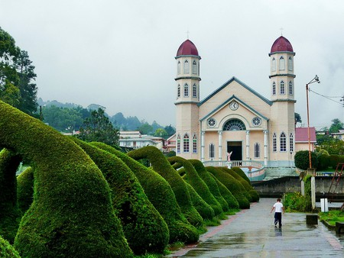Zacero is a picturesque town on the scenic path towards Arenal from San José. This is a small town in Costa Rica with coffee farms, sugar cane plantations, and lush forests. It is also much cooler up here than in other parts of Costa Rica, which makes for a nice change after traveling around the coastal zones. One of the most popular attractions is a [topiary garden](http://www.atlasobscura.com/places/parque-francisco-alvardoa), which has over 120 hedge sculptures and archways. There are plant sculptures shaped like elephants, giraffes, dinosaurs, humans, and even cars.

**San Isidro de El General**

San Isidro de El General is a truly unique place to visit in Costa Rica. The town is home to several traditional festivals, including Fiesta Civica (known for its bullfighting, live music and ceremony honoring the patron saint San Isidro). Attending one of these festivals is a wonderfully authentic cultural experience. San Isidro is also a bird lover’s Paradise like the quetzal. It is a very important agricultural zone in Costa Rica, producing fruit (especially pineapple), sugar cane, and coffee.

**Sarchí**

The small town of Sarchí is famous for its crafts and [painted oxcart wheels](https://theculturetrip.com/central-america/costa-rica/articles/a-guide-to-costa-ricas-colorful-oxcart-art/). If looking for quality, handmade Costa Rican art and crafts. Arriving to Sarchí takes an easy day trip from San José. Anyone who enjoys taking photographs will have a field day here.

**Puerto Viejo de Talamanca**

Overall, the Caribbean coast of Costa Rica is still underrated and under-visited in comparison to the Pacific coast. Puerto Viejo is a vibrant, laid-back yet lively beach town that should definitely not be overlooked. The town has a great selection of restaurants, [some of the best nightlife](https://theculturetrip.com/central-america/costa-rica/articles/a-nightlife-and-happy-hour-guide-to-puerto-viejo/), and easy access to multiple beaches, great snorkeling, and lush tropical rainforest. There are tons of exciting tours and activities to choose from, including rainforest hiking, surfing, snorkeling, zip lining, horseback riding, and sea turtle tours.

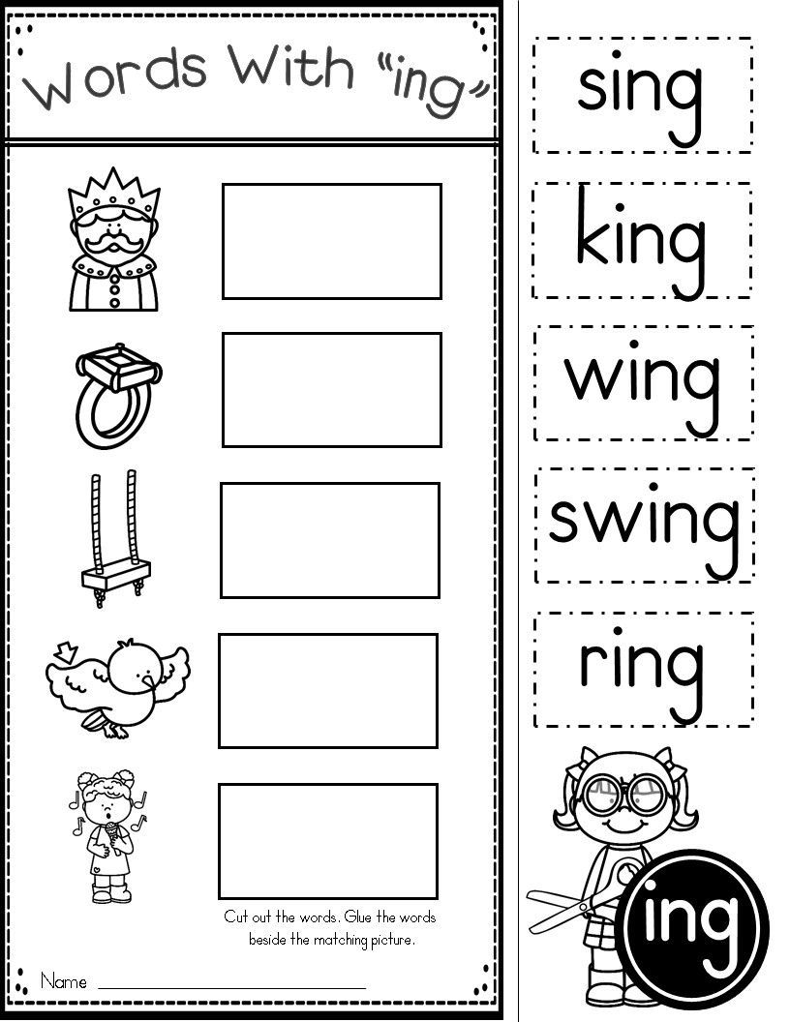

Final del formulario

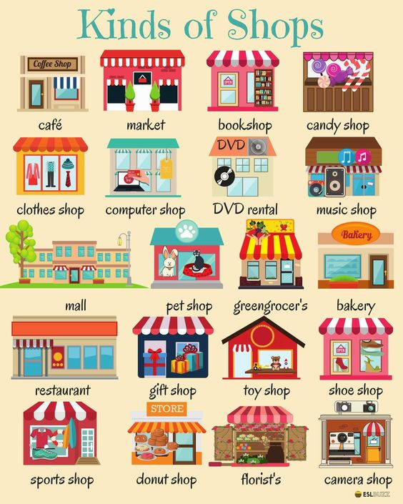

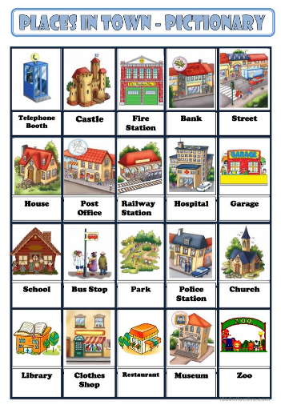

|  |  |  |  |  |  |  |  |  |  |
| --- | --- | --- | --- | --- | --- | --- | --- | --- | --- |
| **Term: I** | | **Level: Fifth Grade** | | | **Unit: 2** | | | **Week:2** | |
| **Domain: Socio-interpersonal** | | | | **Scenario: Pura Vida in many ways.** | | **Theme:** 2. What Makes your Province Unique? | | | |
| **Enduring Understanding**: Our occupations, traditions, music, the way we celebrate, the kind of food we eat, and the way we dress make us unique between provinces in Costa Rica. | | | | | | | | | |
| **Essential Question: How does the place where we live define us?** | | | | | | | | | |
| |  | | --- | | **Dimensions** | | **1.** **Ways of thinking ( X  )** | | **2. Ways of living in the world  ( X )** | | **3. Ways of relating with others  ( X )** | | **4. Tools for integrating with the world  ( )** | | | | | | | | | | |
| **Learn to Know** | | | | **Learn to Do** | | **Learn to Be and Live in Community** | | | |
| **Grammar & Sentence Frames**  Interrogatives   * What are the most popular activities/celebrations in your community/country?   In Costa Rica we _____.   * What do people do to celebrate ___?   We cook/ dress…  Adjectives   * size: long celebration, small parade * shape: round, square * colors: white hat, red skirt   **Phonemic Awareness**   * Identifying inflectional endings (e.g., -s, -ed, -ing, etc.) and their functions (i.e., tense, plurality, comparison and parts of speech).   Writing the letters heard in a word in proper order.  **Vocabulary**  2. What makes your province unique?  Expressions and phrases   * What the most important celebrations in town? * How do you celebrate it?   Holidays & Celebrations   * Saint Patron´s Day, community fair, civic parties, holidays   Typical cuisine   * Rice with chicken, picadillos, soups, grilled beef   Typical dressing   * School uniform, t-shirt and jeans, a hat, boots | | | | **Function**  **Function**   * Describing my province traditions, music, occupations, foods, celebrations, dress code and people among other aspects   **Discourse Markers**  First, second, third… | | **Psycho-social**   * Respecting other customs and traditions   **Sociocultural**   * Holidays and celebrations   **Idioms/phrases**   * Cat nap (short sleep) I am going to have a cat nap while you are cooking dinner. | | | |
| **Assessment Strategies & Evidences of learning**  (Diagnostic, formative, summative) | **Goals** | | | **Pedagogical Mediation/ Didactic Sequence** | | | | | **Time** |
| Learner… | Learner can | | | **Pre-teaching**  Share the Essential question on the board, “How does the place where we live define us?” Write ideas on the board. Then, review them with students.  **Connection**  **Warm up**  Students watch the video about Costa Rica culture, traditions, food, plants and animals. Teacher asks Students if they liked the video and what was something they liked about the video.  <https://www.youtube.com/watch?v=KxOwGzaBpmg>  **Activation of Prior Knowledge**  Teacher writes on the board the words: Food, Animals, Songs, activities.  Teacher asks: What are the most popular activities, in Costa Rica?  What is some traditional food in Costa Rica or in the place you live?  What food is popular in CR or in the place you live?  What are some typical songs in our country?  **Modeling**  Students watch the video about community fairs and “cimarronas” in Costa Rica. <https://www.youtube.com/watch?v=Rj6oMKWfeTU>  Teacher introduces some traditions people do in Costa Rican with pictures. Saint Patron´s day, community fair, civic parties, and holidays. What activities do you do in the place you live? Do you have community fairs? Do you like community fairs? What do you enjoy the most in community fairs? What holidays do you celebrate in your town?  When there is a community fair people eat / do / wear…..  In my community people celebrate with a big / small parade. It is a long celebration…..  **Clarification**  **Clarifying**  Teacher clarifies vocabulary and sentence frames using questions. In groups, students create a conceptual map with information of the tradition they like the most. They write the name, draw the tradition and write why they like it. Students present it orally and in written form.  You can share the information, for example:  This is San Pablo’s community fair.  People eat corn and tamales.  There is a “cimarrona” the day of the Saint.  I like to go to the fair and to dance with the “mascarada”.  People enjoy sharing with friends, eating food, and listening to music.  People go to the festival with the family.  Teacher asks questions like: When is the tradition celebrated? What do people wear this day? Tell me about the things you can find here. | | | | | 40 minutes |
| **L2.** Recognizes the main points in short, simple stories and reports when there is some previous understanding of the topic and if they are read slowly, clearly and possibly repeated.  **L2.1.** gets the gist of a short simple stories and reports about town places and activities after first listening.  **L2.2.** recognizes the main points in short, simple stories and reports about town places and activities when there is some previous understanding of the topic and if they are read slowly, clearly and possibly repeated. | **L2.** understand the main points in short, simple stories and reports when there is some previous understanding of the topic and if they are read slowly, clearly and possibly repeated. | | | **Connection**  **Pre-task**  Teacher shares the goal of the lesson. Teacher reviews last lesson by making a spider web of the traditions the students chose in the brochures. Teacher makes an organizer or spider web to present the ideas brainstormed.  **Pre-listening task: Teacher asks students:**  What are some Costa Rica´s cultural expressions?  What type of food is found in “turnos” or “puestos” in the country?  What are some traditions communities have when celebrating a party?  What do people do when there is a community fair?    **Clarification**    **Task-rehearsal**  Students listen to and watch the video: Cultures & Traditions Costa Rica.  <https://www.youtube.com/watch?v=h5JgRiLCIHk>  Students comment on some things they observed and listened to in the video.  What is the video about?  What places do you recognize?  Have you visited a local fair?  What food do you eat in local fairs?  **Construction/Application**  **Task completion**  Watch the video again and answer to the following questions and listen to the video again. <https://www.youtube.com/watch?v=h5JgRiLCIHk>   |  |  | | --- | --- | | **Questions** | **Answers** | | What is the Costa Rica´s symbol of labor? |  | | What are local fairs called? |  | | What are Costa Rica´s most important landmarks? |  | | What can you see in local fairs? |  | | What type of music do you hear in local fairs? |  |   **Collaboration**  **Task assessment**  Students are divided in several groups. Teacher is going to ask the groups some questions related to traditions, music, occupations, foods, celebrations, dress code and people among other aspects. The students take turns between them and answer by raising their hands.  Example:   * Mention 2 holidays or celebrations in Costa Rica. * What is a typical food from your community? * What type of music do you hear in a local fair? * What do people dress in Annexation of Guanacaste day? * Mention a popular drink in your community. | | | | | 40 minutes |
| **SI.2.** Exchanges information about everyday matters using simple vocabulary (e.g., favorite sports, holidays, music, food).  **SI.2. 1.** asks simple questions about topics such as favorite sports, holidays, music and food.  **SI.2. 2**.responds to simple questions about topics such as favorite sports, holidays, music and food. | **SI.2.** exchange information about everyday matters using simple vocabulary (e.g., favorite sports, names of pets, holiday plans). | | | **Connection**  **Pre-task**  Teacher shares the goal of the lesson.  Students with the help of the teacher brainstorm forms studied before for asking for clarification of vocabulary like the following:   * What type of music do people play in civic parties? * What are the most popular activities/celebrations in your community/country?   In Costa Rica we _____.  What do people do to celebrate ___?   * What are you going to listen in the community fair? I am going to listen to……… * What are you going to do in new year? I am going to have a cat nap while dinner is ready.   Teacher provides feedback and more information.  **Clarification**  **Task-rehearsal**  Students are going to watch the following video about Costa Rica culture and traditions. Stop at 2:30.  <https://www.youtube.com/watch?v=AgzsYgXnnBU&t=17s>  Teacher brainstorm ideas on the board about Costa Rica´s culture and traditions. Teacher clarifies vocabulary and sentence frames  **Collaboration**  Students get in pairs and the name of some typical food in Costa Rica. (Annex 1)  Students in pairs are going to ask and answer the following questions given by the teacher as a way to exchange information.  What is some traditional food in Costa Rica or in your community?  What is a very popular dish in your community or province?  What do Costa Rican people cook when there is a party?  What is your favorite celebration?  What do you eat? Is there any special type of food?  **Construction/Application**  **Task completion**  After students watch the video for the second time, students get in groups of 3 students. One part of the classroom pretends to be from another country and want to visit Costa Rica, they will prepare at least five questions they want to asks to know more about Costa Rica´s culture and traditions., The other part of the class will get ready to explain the traditions, music, occupations, foods, celebrations, dress code and people among other aspects in their community or province.  Students take into consideration the following questions.  What is a popular community fair in the place you live?  What do people do in holydays? (New Year, Christmas, Holyweek, your birthday, Independence Day.)  What is the most popular celebration in your community?  What type of food can you find in community fairs?  What do people dress in local fairs?  What do people eat in local fairs?  What type of music do people like to hear and dance in community fairs?  **Collaboration**  **Task assessment**  Students work in groups and one member of the group goes to the board and tries to draw traditions, types of music, occupations, foods, celebrations in Costa Rica. The rest of the group will guess the drawing and will provide a complete sentence.  Example: Tamales. I eat tamales in Zapote. | | | | | 40 minutes |
| **R2.** Recognizes and enjoys texts.  **R.2.1.** gets the gist in short simple texts after first reading.  **R.2.2**. responds to questions completing diagrams and/or maps.  **R.2.3**. examines the main points of texts for making decisions and recommendations about best places and activities in the community. | **R.2.** comprehend reading, analyze and enjoy texts. | | | **Connection**  **Pre-task**  Teacher shares the goal of the lesson.  Teacher shows typical dress or typical clothes that represent people from Costa Rica and tells the students about the clothes.  Teacher asks students the questions:  What is the traditional dress in Limón?  What do children wear if they are students?  What is Costa Rica´s national dress?  What colors can you see when people dance typical songs?  Teacher writes on the board the following descriptions of what people wear in Costa Rica. Teacher shows some pictures.  In Costa Rica, boys wear a hat, jeans and boots when they work on a farm.  Children wear a uniform when they go to school.  For Annexation of Guanacaste Day, people wear a typical dress.  In Limon, people wear colorful dress and long skirts.    **Collaboration**  **Task-rehearsal**    Students read the description of Costa Ricans typical clothing. After that, students in pairs or groups of three are going to create an organizer or spider web to brainstorm their ideas about Costa Rica clothes and celebrations.  Students take a look at the pictures from Costa Rica, they complete a graphic organizer with their ideas.  Por una Guanacaste con más festivales de arte y cultura!  **Construction/Application**  **Task completion**  **Reading:** <http://adventure-costarica.com/travel/costa_rica_general_information/cultural_events_festivals.htm>  Students read the text  . Then complete the exercise by writing (F) if the statement is False, or (T) if it is True.   1. Costa Rica´s festivals show a mix or cultures:_________ 2. These events are inside and outside Costa Rica:_________ 3. Many festivals in CR are in memory of civil and religious events. ________ 4. Processions and parades are not part of the festivals:_________ 5. Oxcarts are decorated with animals:________ 6. Children wear typical traditional costumes in festivals:_________   **Collaboration**  **Task assessment**  Students in pair or groups choose two of the celebrations that are in the blog and read them. (Annex 2) <https://www.costaricatesol.com/tefl-costa-rica-blog/festivals-fairs-in-costa-rica-285>  After they read the celebrations, students choose their community or province and complete the chart.  **Name:_______________________________**   |  |  |  |  | | --- | --- | --- | --- | | **Activity people do** | **Music played** | **Food people eat** | **Clothes people wear** | |  |  |  |  |   Students share their chart. Teacher provides feedback. | | | | | 40 minutes |
| **R.PA.1.** Distinguishes phonemes for inflectional endings (-ing, -ed and –s).  **R.PA.1.2.** recognizes phonemes for inflectional endings (-ed) by selecting words heard with that phoneme. | **R.P.A.1.** distinguish phoneme for inflectional endings (-ing, -ed and –s). | | | **Connection**  **Pre-task**  Teacher shares the goal of the lesson.  Teacher shows a list of verbs and ask students to identify what they have in common.  **Played- gained – enjoyed – showed – talked – watched.**  Students watch the video: <https://www.youtube.com/watch?v=jxl28KQOHy4>  Teacher explains that the video shows the way of using suffix -ed for talking about actions in the past and their pronunciation  Students will watch the video that explains the three sounds in prefix -ed, provides examples and asks students to repeat several times.  <https://www.youtube.com/watch?v=msJIy_f_Xsw>  Teacher explains the use of suffix -ed in verbs, the rules and some examples to students.  **Clarification**  **Task-rehearsal.**  What did I learn about -ed pronunciation? Let´s practice! (Annex 4)  Students cut the words, listen to the teacher saying the word two times and classify the word in the correct final sound column. -ed. /d/ /t/ /ed/    Taken from:[**https://www.education.com/worksheet/article/what-does-ed-say/**](https://www.education.com/worksheet/article/what-does-ed-say/)  Students check answers in pairs. Then, teacher checks the answers with whole group to give feedback. Students repeat.  **Construction/Application**  **Task completion**  Students add the suffix -ed to each word. Annex 3.  Then, students practice the pronunciation of the words they formed orally.  Teacher checks the pronunciation by asking students to repeat.  **Collaboration**  **Task assessment**  Students complete the Annex 4. In groups, teacher gives students some boots with words with the suffix -ed, and 3 clouds with the correct pronunciation. Students put under the correct pronunciation cloud the word they hear.  Teacher checks and provides feedback.  **Student self-assessment grid**   |  |  |  |  | | --- | --- | --- | --- | | **Level of achievement** | | | | | **Assessment Indicators**  **I can ..** | ***C:\Users\mcastilloh\Downloads\descarga.jpg*Not achieved yet** | **In progress**  ***C:\Users\mcastilloh\Downloads\Grinning-Face-with-Smiling-Eyes.png*** | **Achieved**  ***Resultado de imagen para happy emoji*** | | **L2.1**. gets the gist of a short simple stories and reports about town places and activities after first listening. |  |  |  | | **L2.2.** recognizes the main points in short, simple stories and reports about town places and activities when there is some previous understanding of the topic and if they are read slowly, clearly and possibly repeated. |  |  |  | | **R.2.1.** gets the gist in short simple texts after first reading. |  |  |  | | **R.2.2.** responds to questions completing diagrams and/or maps. |  |  |  | | **R.2.3.** examines the main points of texts for making decisions and recommendations about best places and activities in the community. |  |  |  | | **SI.2. 1.** asks simple questions about topics such as favorite sports, holidays, music and food. |  |  |  | | **SI.2. 2.**responds to simple questions about topics such as favorite sports, holidays, music and food. |  |  |  | | | | | | 40 minutes |
| **Integrated Mini-Project** | | | | | | | | | **Time** |
| * **Planning** and **creating collaboratively**   a collage and /or a foldable about main attractions and celebrations in my community, province, and country.   * **Rehearsing** the presentation and **reporting it** in oral and written form to the class. * **Participating** in self and co-assessment using technically designed instruments. | | | | | | | | |  |
| **Reflective Teaching** | | | | | | | | | |
| What worked well | | | What didn’t work well | | | | How to improve | | |
| **Enduring Understanding Reflection** | | | | | | | | | |
|  | | | | | | | | | |



Annex 1. Taken from <https://en.islcollective.com/english-esl-worksheets/skill/spelling/costa-rican-typical-food/6246>

Annex 2.

[Fiestas Palmares](https://www.facebook.com/FiestasPalmares2018/?ref=br_rs) 

Every year in January, Costa Ricans descend on the town of Palmares in the south of the province of Alajuela.  The festival is famous for its "tope," which is a parade of horses and all things country western, its concerts and its beer drinking.  They get some pretty big names to come for the concerts; I saw Calle 13 a few years ago!  There are also carnival rides and stands to buy food.  You can take a public bus from San Jose to get there, but people tend to get a group of friends and family together to rent a van and a driver (Safety first, people!), and tour companies even put packages together.  Don't miss this one!

[Carrizal](https://www.facebook.com/festejoscarrizal2017/)

Also in January is the festival in Carrizal, which is a small town in the mountains between Barva and Poas Volcano.  Similar to the festival in Palmares, they have carnival rides and food stands in addition to concerts, dances and bull riding.  My favorite day to go is to see the "carnaval" with the Caribbean flare of Costa Rica, so check the calendar. To get to Carrizal, you can take a bus from Heredia or even hop on in front of the church in Barva.

[Envision](https://envisionfestival.com/)

Every February, thousands of locals and international travelers take over the Pacific coastal town of Uvita to take part in the Envision Festival.  Envision is a celebration dedicated to providing a platform for different cultures to co-exist in a sustainable community and to inspire through art, spirituality, yoga, music, education, and a connection with nature.  You have to purchase tickets and hostels and hotels fill up quickly, so start planning now!

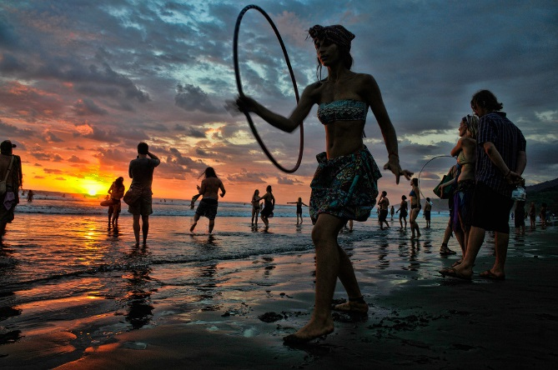

[Carnavales de Puntarenas](http://puntarenas.com/carnavales/carnaval.html)

Like the famous Carnival in Brazil, Puntarenas hosts the biggest carnival in Costa Rica before the Christian season of Lent starts every year.  Enjoy the music, dancers, bands, costumes and masks during the parade, and don't miss the beauty contest and sports competitions!

[Dia Nacional del Boyero](https://www.facebook.com/Dia-Nacional-del-Boyero-en-Escazu-322241780043/)

The Costa Rican tradition of using oxcarts to transport goods is celebrated with a parade of colorfully and elaborately painted carts pulled by oxen on the second Sunday in March in San Antonio de Escazu.  Many craft and food vendors are also present in the festival, so enjoy the summer sun and check out this unique Costa Rican festival.

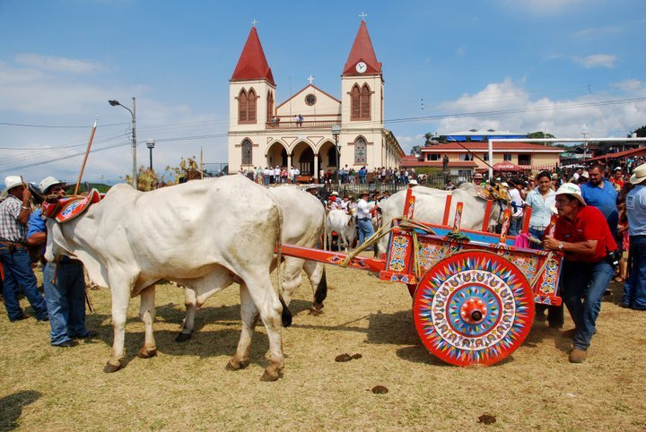

[Festival de las Artes (FIA)](https://www.facebook.com/festivaldelasartescr/)

The Festival de las Artes is a government-sponsored program designed to promote and develop local art and the diversity of the arts and the artists.  Each year in July, the program packs 11 days with art, music, theatre, literature and cinema to fill San Jose with culture, happiness and color.  Lots of the displays and events are in public venues and are free!

[Barva Festival](https://www.costaricatesol.com/tefl-costa-rica-blog/august-barva-festival-83)

Every August, we get front row seats to the festival here in Barva-Heredia.  The town celebrates two weeks of festivities revolving around the patron saint, Bartholomew. The festival is known for its mask festival. The town's teenagers and young adults wear masks, carry water-filled pig or cow bladders and follow a small, traditional band around the streets of downtown Barva. If you would rather not be hit by a foul bladder, we recommend standing behind the fence on the church's property. Barva is a ten-minute bus ride from downtown Heredia.

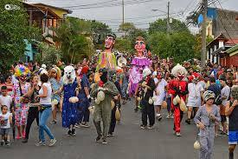

[Carnavales de Limon](https://www.facebook.com/carnavalesdelimon2017/)

Every October, Costa Rica celebrates the Dia del Encuentro de Culturas and its Afro-Caribbean culture with parades, calypso music, colorful and elaborate costumes, dancing, concerts, and delicious food like coconut-flavored rice and beans (known locally as "rice and beans"), fried green plantains (patacones), and jerk chicken.  Puerto Limon is the main port of the Costa Rica's Caribbean coast and can easily be reached by public bus from San Jose.

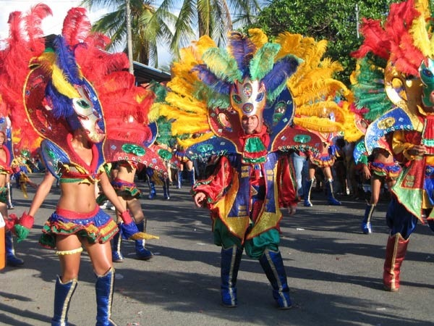

[Festival de la Luz](http://www.festivaldelaluz.cr/)

Normally the second Saturday in December, the best marching bands of Costa Rica and some fun floats take over the streets of San Jose in the evening for the Festival de la Luz.  It's a fun way to start the Christmas season, but get there early because people start making camp on the sidewalks in the morning!

[Tope Nacional/National Horse Parade](http://www.detope.com/index.php?option=com_eventlist&view=eventlist&Itemid=48)

Yes, there are a number of "topes" in Costa Rica throughout the year, but you can't miss the Tope Nacional in San Jose on December 26.  "Topar" is the Spanish verb to round up the cattle, and the events are full of great pride for Costa Rica's cowboy and rancher culture.  Many of the horses and riders display great style and elegance, and the spectators line the streets in their best cowboy garb.

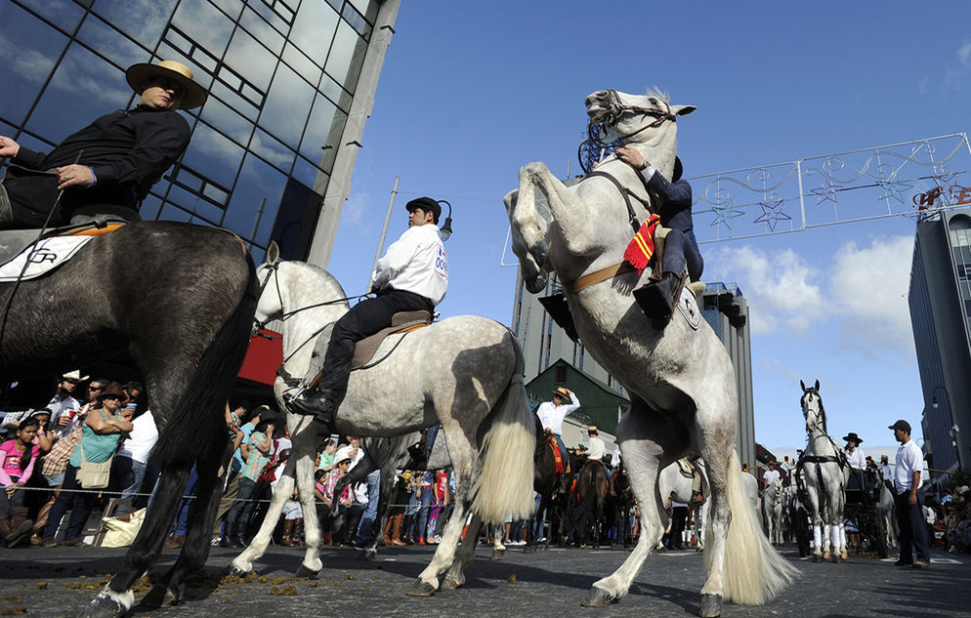

[Fiestas de Zapote](https://www.facebook.com/Fiestas-Zapote-135740923133873/)

Depending on the year's calendar, the Fiestas de Zapote start on or near December 25th and end around January 1st.  Costa Ricans love to indulge in this celebratory time of year by spending at least one day in Zapote and by watching the festivities on TV.  Zapote also features the normal fairgrounds and concerts, but it is famous for the daily bull fights.  Have no fear, these are not the bull fights from Spain or Mexico that come to mind; although the bulls are taunted, they are not physically harmed.  From downtown San Jose, you can take a public bus or a taxi to Zapote, which is southeast of the city.

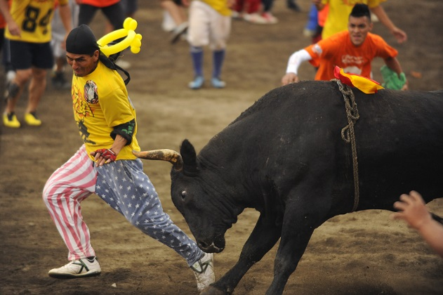

Yes, we know you came to Costa Rica for the wildlife and beaches, but don't forget to experience the culture by taking in some of these festivals during your time here!  And if you haven't yet registered for one of our [4-week, onsite TEFL courses](https://www.costaricatesol.com/tefl-courses), [contact us today](https://www.costaricatesol.com/about/contact)!

Annex 3. Taken from: <https://en.islcollective.com/english-esl-worksheets/grammar/suffixes/ed-suffix/39225>



Annex 4.

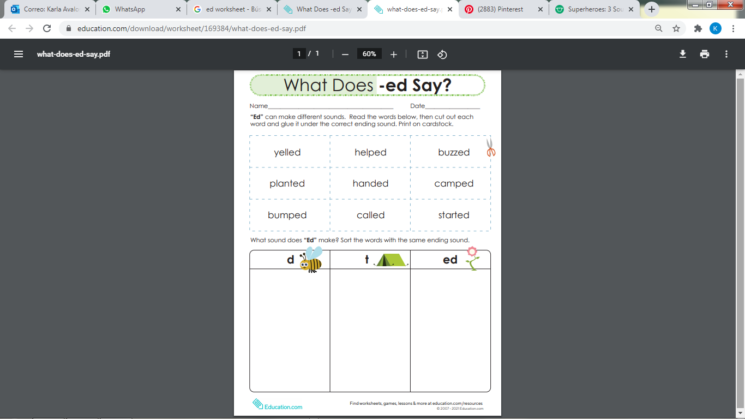

Annex 5.

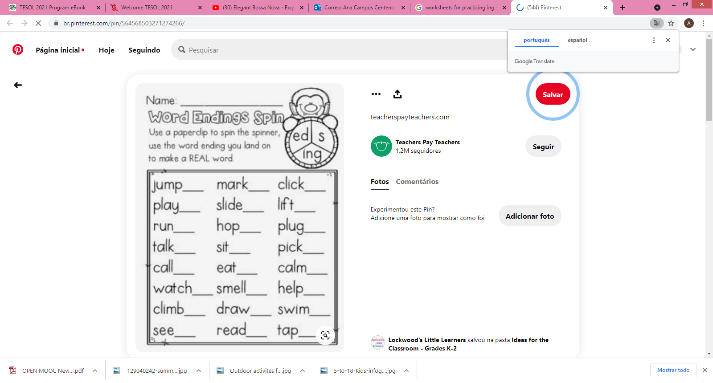

Annex 6. Taken from <https://www.teacherspayteachers.com/FreeDownload/Rainy-Day-Suffix-ed-Sort-336827>

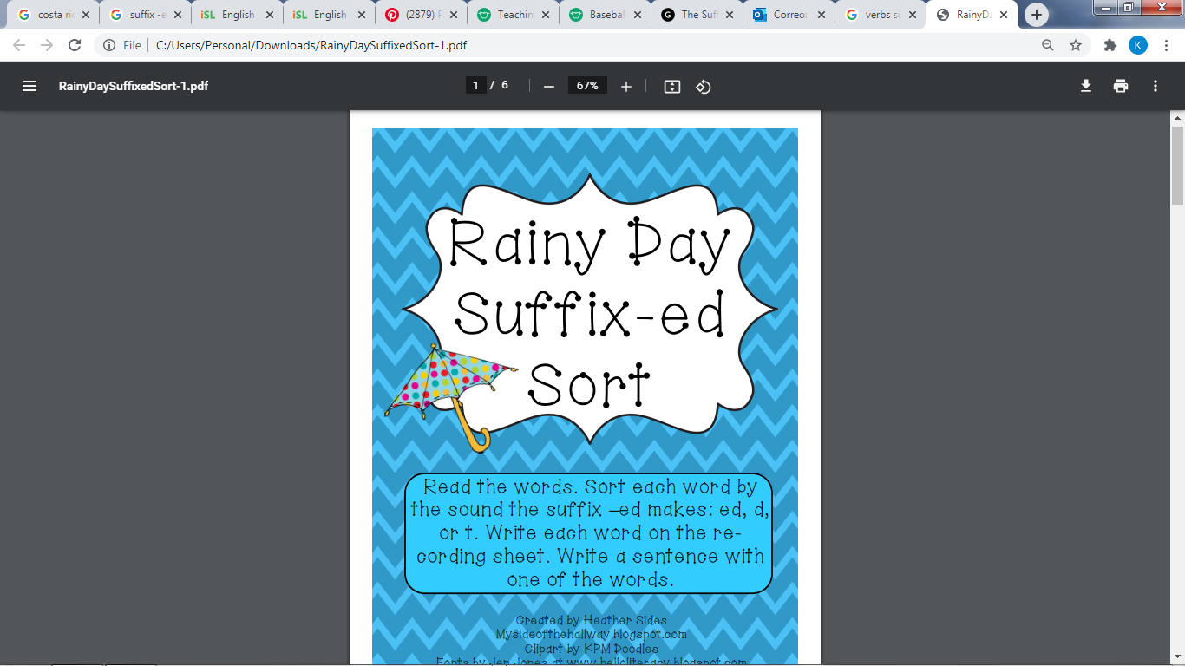 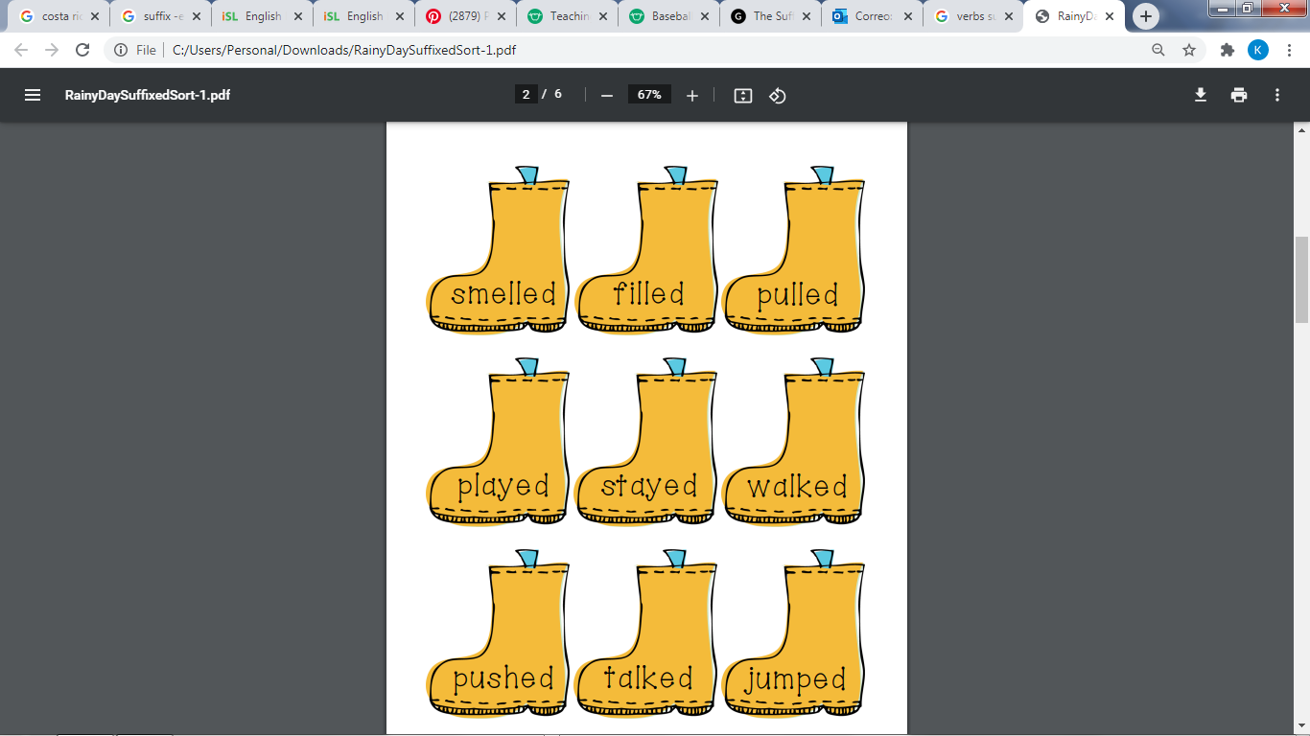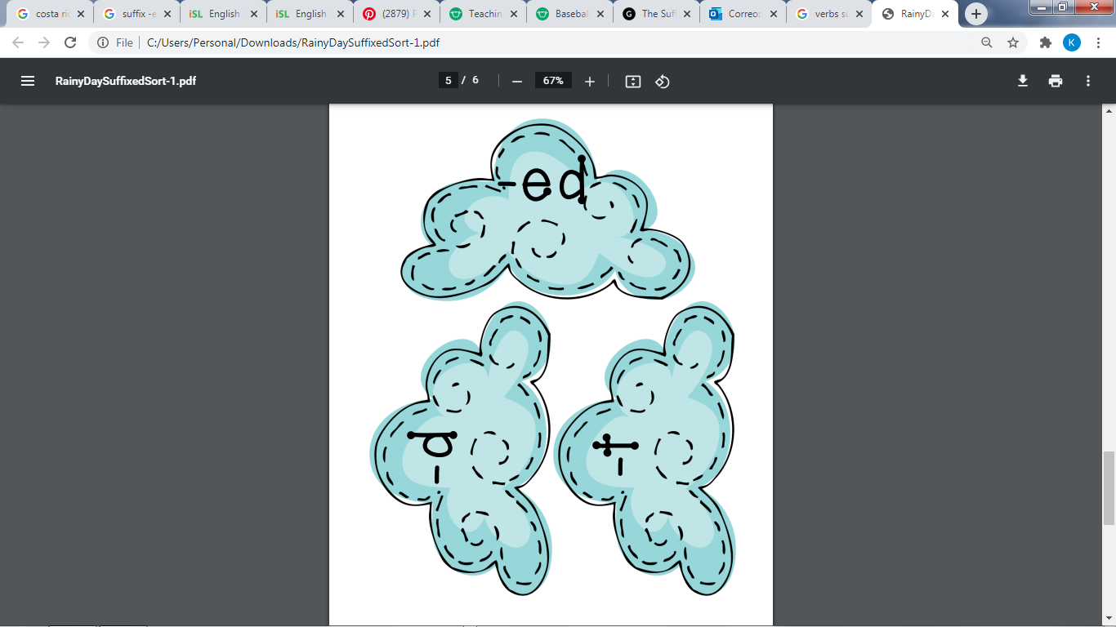

|  |  |  |  |  |  |  |  |  |  |
| --- | --- | --- | --- | --- | --- | --- | --- | --- | --- |
| **Term: I** | | **Level: Fifth Grade** | | | **Unit: 2** | | | **Week:3** | |
| **Domain: Socio-interpersonal** | | | | **Scenario: Pura Vida in Many Ways** | | **Theme:**  Costa Rica: “No Artificial Ingredients” | | | |
| **Enduring Understanding**: Our occupations, traditions, music, the way we celebrate, the kind of food we eat, and the way we dress make us unique between provinces in Costa Rica. | | | | | | | | | |
| **Essential Question:** How does the place where we live define us? | | | | | | | | | |
| |  | | --- | | **Dimensions** | | **1.** **Ways of thinking (   X)** | | **2. Ways of living in the world  ( X )** | | **3. Ways of relating with others  ( X)** | | **4. Tools for integrating with the world  ( )** | | | | | | | | | | |
| **Learn to Know** | | | | **Learn to Do** | | **Learn to Be and Live in Community** | | | |
| **Grammar & Sentence Frames**  Superlative forms  The most beautiful beach of my province is_____.  The best food to eat is ________.  The highest mountain is _______.  **Phonemic Awareness**  **Vocabulary**  Costa Rica: “No artificial ingredients**”**  Expressions and phrases   * Where are you from? * What is Costa Rica like? * What are the best places to visit? * Which are the most important celebrations?   Places to go   * Beaches, volcanos, rainforests, wildlife islands.   People to meet   * Indigenous communities (bribris, cabecares, malekus, Ngobes) * Afro-descenden * Costa Rica is Multicultural and plurilingual | | | | **Function**  Describing Costa Rica  **Discourse Markers**  First, second, third… | | **Psycho-social**   * Celebrating the differences between culture   **Socio-cultural**   * Loving diversity in Costa Rica and countries around the world   **idioms/ phrases**   * Don´t count your chicken before they hatch (don´t make plans ahead of time) | | | |
| **Assessment Strategies & Evidences of learning**  (Diagnostic, formative, summative) | **Goals** | | | **Pedagogical Mediation/ Didactic Sequence** | | | | | **Time** |
| Learner…  **L3.** Recognizes the most important points in a straightforward talk or presentation, accompanied with drawings and/or diagrams, provided there was some previous familiarity with the topic  **L3.1**. gets the gist of the most important points in a straightforward talk or presentation about places and activities in the community provided there was some previous familiarity with the topic.  **L.3.2**.recognizes the most important key points in a straightforward talk or presentation, about places and activities in the community accompanied with drawings and/or  **R3.** Follows a set of clear-cut instructions, especially if there are pictures or diagrams to illustrate the most important steps.  **R.3.1.** recognizes some clear cut instructions presented in different short texts about location and main attractions in the community  **R3.3.** follows a set of clear-cut instructions, especially if there are pictures or diagrams to illustrate the most important steps.  .  **R.PA.1.** Distinguishes phonemes for inflectional endings (-ing, -ed and –**s**).  **R.PA.1.1.** recognizes phonemes for inflectional endings (-s) by selecting words heard with that phoneme.  **W1.** Engages in the writing process: pre-drafting, drafting  **W.1.1** brainstorms a list of main ideas for topic as a form of pre-writing.  **W.1.2**.makes an outline to organize the main ideas using phrases and short sentences.  **W.1.3.** creates a draft of text writing complete sentences for each main idea and supporting details.  **SP1.** Expresses short advices and recommendations  **SP.1.1.** recognizes different vocabulary, phrases and expressions about giving short advices and recommendations about places to visit in the community.  **SP.1.2.** gives short advices and recommendations about places to visit in the community and in the country in a real life situation. | Learner can  **L3.** understand the most important points in a straightforward talk or presentation, accompanied with drawings and/or diagrams, provided there was some previous familiarity with the topic.    **R.3.** follow a set of clear-cut instructions, especially if there are pictures or diagrams to illustrate the most important steps.  **R.P.A.1.** distinguish phoneme for inflectional endings (-ing, -ed and –**s**).  **W1.** engage in the writing process: pre-drafting, drafting.  **SP1**. Express short advices and recommendations | | | **Annexes and files necessary for developing this week can be downloaded from**  https://recursos.mep.go.cr/sitio_primaria_ingles/quinto.html  **There is also a link to each file in its corresponding activity**  **Pre-teaching**  **Routine:** Checking attendance, checking in with Ls, T posts the Essential Question on the board, Can Do´s, and class agenda, etc.  **Essential Question:** How does the place where we live define us?  T explains the goal of the lesson.  **Connection**  **Warm up**  The teacher shows the YouTube video: “Costa Rica: No Artificial ingredients”. <https://www.youtube.com/watch?v=BWedIclSdEY> and asks learners to take notes on the different natural beauties they recognize. Learners share their answers in pairs.  **Activation of Prior Knowledge**  T displays a poster available at: <https://recursos.mep.go.cr/sitio_primaria_ingles/quinto.html>  for learners to identify the different natural beauties they see in the images. T asks Ls:  What´s this? What do you see there? What are they doing?  **Modeling**  T asks Ls the following questions: Where are you from? What is Costa Rica like? What are the best places to visit in Costa Rica? Which are the most important celebrations? Are there any indigenous communities in Costa Rica that national and international visitors can visit?  Teacher introduces the sentence frames for the superlative form of the adjectives in English using a power point or images with the sentences, for example:   * Which is the most beautiful beach to visit in your community? The most beautiful beach is Pochote beach. * Which is the longest river in Costa Rica? The longest river in Costa Rica is Terraba river. * Which is the most delicious food in your community? The most delicious food is “casado” with chicken. * Which is the highest mountain in Costa Rica? The highest mountain is Chirripó Mountain.   **Clarification**  **Clarifying**  T clarifies by asking Ls: Why is Costa Rica called a country with “no artificial ingredients”? By using the images from the previous poster, T asks Ls Yes/No Questions: Is this a volcano? Is this a river? Is this a beach? Are they surfing? Is Chirripó mountain or Irazú volcano the highest mountain in Costa Rica?  **Clarification**  **Pre-task**  Teacher reviews sentence frames related with the superlative sentences and reviews vocabulary useful to describe Costa Rica´s natural beauty.  **Collaboration**  **Task rehearsal**  Teacher prepares students to listen to a video that describes the most beautiful places of Costa Rica. Students listen for the first time and will identify the following general information:   1. What are three words that describe Costa Rica based on the information heard? 2. What different ethnic groups can be identified in the video that make us be all Ticos? 3. What city of Costa Rica is mentioned in the video? 4. Can you name three national parks mentioned in the video?   Video link: <https://www.youtube.com/watch?v=0LJBVy457HQ> Students listen up to 2:15 minute  After listening, students share responses first with classmates then with teacher for feedback.  **Construction/Application**  **Task completion**  Students in pairs listen to the video a second time. They will verify their first responses and they will take notes to respond to these specific questions:   1. Which places can tourist visit in the capital city of Costa Rica? 2. What can you see at the Gold Museum? 3. Which magazine describes Corvocado national park as “the richest place biologically speaking of the planet”. 4. What can you find at Corvocado National Park in the South Pacific of Costa Rica? 5. What makes Guanacaste on of the most visited places of Costa Rica?   Students check their responses in pairs.  **Collaboration**  **Task assessment**  Students listen for third time to verify their answers and get feedback from teacher. Students in pairs participate in peer and self-assessment of task.  **Connection**  **Pre-task**  T shows an infographic which contains information related to Costa Rica and its natural beauties. The infographic can be downloaded from <https://recursos.mep.go.cr/sitio_primaria_ingles/quinto.html>  Teacher highlights the use of the superlative form of adjectives to emphasis the value of something or someone to the greatest or the lowest degree: for example: **Costa Rica has the most beautiful beaches in the world.**  Ls read the information provided with more examples. Teacher clarifies any questions.  **Clarification**  **Task-rehearsal**  T provides Ls an incomplete infographic for Ls to label the information provided with its corresponding category related to food, places to visit, activities to do, and location. Teachers provides clear instructions about what learners have to do.  Infographic: <https://recursos.mep.go.cr/sitio_primaria_ingles/quinto.html>  **Construction/Application**  **Task completion**  Read the following text and do the following:   1. Underline all the sentences that use a superlative form of adjectives. 2. Create an infographic with pictures, cutouts or drawings. 3. The infographic has to include a title, pictures, drawings or cutouts and sentences using superlative forms that describe each of the pictures. 4. Include at least five key ideas from the reading in your infographic.   Arenal volcano is the most spectacular and beautiful volcano in Costa Rica. It is located in La Fortuna, San Carlos. It has a perfect cone shape and you can regularly observe clouds on top of its peak. Arenal volcano is surrounded by evergreen forest where you can see many types of animals like raccoons and monkeys. It is also a good point for birds sightseeing. Many people visit the park to enjoy the hot springs, to go hiking and to see the beautiful view of the volcano. In the surrounding area of the volcano you can find restaurants, hotels and spas. There is a good bus service to travel from San José to la Fortuna. At La Fortuna you can find very good restaurants and enjoy traditional Costa Rican food as well as international cuisine.  .  **Collaboration**  **Task assessment**  T provides a chart available at [(click here)](https://adminmepcr-my.sharepoint.com/:b:/g/personal/ever_cordero_gomez_mep_go_cr/ESQl7J_Jh_tHqY60Hct7WdoBkzuuUUDy0ySJ2097SURTjQ?e=5ezsyv) and have each learner interviewing three classmates. They will have to ask and answer the following questions; What is the most beautiful beach in C.R? What is the best Costa Rican dish? What is the highest mountain in C.R? What is the most important celebration? What is the most exciting activity to do?  **Phonemic awareness**  **Connection**  **Pre-task**  T plays a video available at <https://www.youtube.com/watch?v=jyoGmyx8ipw> and have Ls watching it. It is ok if Ls want to pronounce some words.  **Clarification**    **Task-rehearsal**  T divides the class into two teams (or three if it is necessary). T writes on the board the two inflections heading endings **es**- **s.** T calls from thefollowing suggested list a word. Taking turns, a participant of each group places himself/herself under each heading to discriminate correctly each sound.  *Beaches, trails, volcanos, dishes, rainforests, watches, waterfalls, visitors, places, rivers.*  Teacher provides feedback to learners.  **Construction/Application**  **Task completion**  T provides the following worksheet crossword puzzle. Ls find the hidden words related with inflection -***s*** ending sound, once they have found the word Ls write the correct inflection way under the correct given heading sound. T checks their answers orally.  [Download the images from here or copy them from below](https://adminmepcr-my.sharepoint.com/:p:/g/personal/ever_cordero_gomez_mep_go_cr/EXJSsIXtKkVDhxALKe09GxsBoZRP6Dwf3ZR5-ljnSnat4A?e=eQbOZX)      **Collaboration**  **Task assessment**  T provides Ls the following text to be completed using inflection -**s** correctly to show plurals. Learners work in pairs to provide feedback to one another.   |  | | --- | | Costa Rica may have some of the most stunning ____________ (rainforest) and wildlife on the planet, but it also has truly awesome ______________ (beach) on the Pacific and Southern Caribbean _____________. (coast)  In just seven __________ (day) and six _________ (night) you can explore two of the most iconic _____________ (place) in Costa Rica: Arenal and Tortuguero National ____________ (Park).  Explore hot ____________ (spring), rainforest, lava __________ (flow), and wetlands while searching for sloths, _____________ (turtle), myriad birdlife, _____________ (monkey) and more! |   **Connection**  **Pre-task**  T displays a presentation (<https://recursos.mep.go.cr/sitio_primaria_ingles/quinto.html>  ) with visual material such as an advertisement, a poster, an infographic, and a video to review the vocabulary related to Costa Rican natural beauties.  **Clarification**  **Task-rehearsal**  T asks Ls to get in pairs to brainstorm ideas in order to create their own written advertisement to invite a tourist to come visit Costa Rica. <https://recursos.mep.go.cr/sitio_primaria_ingles/quinto.html>  Brainstorm ideas related to: location, food, activities, attractions, and possible cost using a mind map. Teacher shows examples about how to do it and clarifies questions.    **Construction/Application**  **Task completion**  In pairs, students make an outline with complete sentences or phrases as a way to organize their main ideas to create an advertisement about the most important attractions of the community.  Ls design a first draft of an advertisement about the most beautiful attractions, the best food to eat, location and the most exciting activities to do in Costa Rica with teacher’s support. <https://recursos.mep.go.cr/sitio_primaria_ingles/quinto.html>  **Collaboration**  **Task assessment**  Ls in groups publish and share their written advertisements to create a wall gallery in the classroom.  **Connection**  **Pre-task**  T talks about his/her own vacation plan following the structure given:  First, I will go to... because it is the most beautiful place in Costa Rica.  Second, I will visit...  Third, I will travel to...  Finally, I recommend you to visit …. because the food is delicious, the scenery is very beautiful.  **Clarification**  **Task-rehearsal**  T divides the group into two teams.  Each member of Team A (presenters) will have a station in the wall gallery created in the last lesson. They will stand near their own poster; Team B (local tourist), walk around to observe the whole gallery and take notes about the places they would like to visit, food that they would like to eat, and activities that they would like to do. Team A will also get ready to recommend those places to their partners (Team B tourist).Then Ls will exchange roles.  **Construction/Application**  **Task completion**  Student using the pictures will give a tour of the places they would like to visit and they would recommend to visitors. Each team will visit the wall gallery again. This time starting with team B.  T provides them a chart (<https://recursos.mep.go.cr/sitio_primaria_ingles/quinto.html>  ) with questions and information to check outduring their tour. Ls switch roles, now Team A is the presenter and Team A is the local visitor.  **Collaboration**  **Task assessment**  After having visited the stations, Ls will recommend with their peers in a mingling activity three places that they decided to visit, food that they would like to eat and activities they would like to do. T might give them the following script: <https://recursos.mep.go.cr/sitio_primaria_ingles/quinto.html>  First, I recommend you to go to... because it is the most beautiful place in Costa Rica.  Second, You want to visit...because ….  Third, this beach is great...because....  **Student self-assessment grid**   |  |  |  |  | | --- | --- | --- | --- | | **Level of achievement** | | | | | **Assessment Indicators**  **I can ..** | ***C:\Users\mcastilloh\Downloads\descarga.jpg*Not achieved yet** | **In progress**  ***C:\Users\mcastilloh\Downloads\Grinning-Face-with-Smiling-Eyes.png*** | **Achieved**  ***Resultado de imagen para happy emoji*** | | **L3.1**. gets the gist of the most important points in a straightforward talk or presentation about places and activities in the community provided there was some previous familiarity with the topic. |  |  |  | | **R.3.1.** recognizes some clear cut instructions presented in different short texts about location and main attractions in the community  **R3.3.** follows a set of clear-cut instructions, especially if there are pictures or diagrams to illustrate the most important steps.  . |  |  |  | | **R.PA.1.3.** recognizes phonemes for inflectional endings (-s) by selecting words heard with that phoneme. |  |  |  | | **W.1.1** brainstorms a list of main ideas for topic as a form of pre-writing.  **W.1.2**.makes an outline to organize the main ideas using phrases and short sentences.  **W.1.3.** creates a draft of text writing complete sentences for each main idea and supporting details. |  |  |  | | **SP.1.1.** recognizes different vocabulary, phrases and expressions about giving short advices and recommendations about places to visit in the community.  **SP.1.2.** gives short advices and recommendations about places to visit in the community and in the country in a real life situation |  |  |  | | | | | | 40 minutes  40 minutes  40 minutes  40 minutes  40 minutes |
| **Integrated Mini-Project** | | | | | | | | | **Time** |
| * **Planning** and **creating collaboratively**   a collage and /or a foldable about main attractions and celebrations in my community, province, and country.   * **Rehearsing** the presentation and **reporting it** in oral and written form to the class. * **Participating** in self and co-assessment using technically designed instruments. | | | | | | | | |  |
| **Reflective Teaching** | | | | | | | | | |
| What worked well | | | What didn’t work well | | | | How to improve | | |
| **Enduring Understanding Reflection** | | | | | | | | | |
|  | | | | | | | | | |

|  |  |  |  |  |  |  |  |  |  |
| --- | --- | --- | --- | --- | --- | --- | --- | --- | --- |
| **Term:** | | **Level: Fifth Grade** | | | **Unit: 4** | | | **Week:4** | |
| **Domain: Socio-interpersonal** | | | | **Scenario: Pura Vida in many ways** | | **Theme:** In & Out Costa Rica | | | |
| **Enduring Understanding**: Our occupations, traditions, music, the way we celebrate, the kind of food we eat, and the way we dress make us unique between provinces in Costa Rica. | | | | | | | | | |
| **Essential Question: How does the place where we live define us?** | | | | | | | | | |
| |  | | --- | | **Dimensions** | | **1.** **Ways of thinking ( X  )** | | **2. Ways of living in the world  ( X )** | | **3. Ways of relating with others  ( X )** | | **4. Tools for integrating with the world  ( )** | | | | | | | | | | |
| **Learn to Know** | | | | **Learn to Do** | | **Learn to Be and Live in Community** | | | |
| **Grammar & Sentence Frames**  Present Perfect   * I have been to the United States three times. * I have lived abroad. * Have you been abroad?   **Phonemic Awareness**   * Identifying inflectional endings (e.g., -s, -ed, -ing, etc.) and their functions (i.e., tense, plurality, comparison and parts of speech).   -Writing the letters heard in a word in proper order.  **Vocabulary**  In & Out Costa Rica  Expressions and phrases   * Where are you from? * I ´m from Costa Rica. * Have you been abroad? Yes, I have been to Mexico. * Have your father been abroad? Yes, he has been to the United States. * How long are you staying in Mexico? For three weeks. * Which places have you visited? * I have been to ...   Countries and Nationalities   * Mexico Mexican * Canada Canadian * Nicaragua Nicaraguan * Panama Panamanian   England English | | | | **Function**  Describing travel experiences in or out Costa Rica  **Discourse Markers**  First, Second, Third … | | **Psycho-social**   * Celebrating the differences between cultures   **Sociocultural**   * Appreciating the customs from other cultures   **Idioms/phrases**  Don´t count your chicken before they hatch (don´t make plans ahead of time) | | | |
| **Assessment Strategies & Evidences of learning**  (Diagnostic, formative, summative) | **Goals** | | | **Pedagogical Mediation/ Didactic Sequence** | | | | | **Time** |
| Learner… | Learner can | | | **Pre-teaching**  Teacher checks attendance, checking in with Ls, T posts the Essential Question on the board, Can Do’s, and class agenda. As well, T asks Ls for the weather, feelings, day, date, and year.  **Connection**  **Warm up**  Have children sit in a circle. Start by saying "my name is.." and then answer a question about yourself. For example "My name is Max and I like the color purple." The next person says "This is Max and he likes the color purple and my name is Rose and I am 8 years old." The next person says "That is Jo he likes purple, this is Rose and she is 8 and I am Jeremy and I like the color blue." It's a chain and the kids have to repeat what the last people have said about themselves. It's really hard to be the last person in the circle!  **Activation of Prior Knowledge**  Learners observe as the teacher plays a video.  Video link: <https://www.youtube.com/watch?v=PGWePJfmgOw>  Then, Ls are given a graphic organizer to be completed based on the content observed during the video:  Graphic Organizer Template   * In the middle of the graphic the teachers writes “Costa Rica Provinces”. Then, Ls complete the others areas with info based on the video. * T has Ls share their ideas once watched the video. * As well, teachers asks Ls, Have you been to Arenal Lake? Or Have you been to Limón?   **Modeling**  T models language by means of the “ I See, I Use” activity. For this, learners have to engage in the production of vocabulary and the use of different sentence frames with the guidance of the teacher.  Guanacaste  Example: I see an iguana.  I see _________________________________.  I see _________________________________.  Questions:  Have been to Guanacaste? Yes, I have. / No, haven´t.  What have you done in Guanacaste?  I have rode a horse  I have walked on the beach  **Clarification**  **Clarifying**  Teacher clarifies vocabulary seen and studied from the very beginning in terms of Form, Meaning, and Use. He/she emphasizes vocab-words related to occupations, traditions, music, celebrations, food, activities Costa Ricans do in different places of the country. For this, the teacher uses flashcards. Teacher will emphasize sentence frames using the present perfect tense:  Have been to Guanacaste? Yes, I have. / No, haven´t.  What have you done in Guanacaste?  I have rode a horse  I have walked on the beach  As well, the teacher clarifies the accurate use of sentence frames. For this, he plays the hot potato. Every time a student gets the potato, the teacher asks a question in the present prefect or solicits the student to ask someone a question. | | | | | 40 minutes |
| **SI.1.**Asks straightforward questions in familiar situations and understands the responses.  **SI.1.2**.asks straightforward questions to peers and friends about activities around their community and province. | **SI.1.**Ask straightforward questions in familiar situations and understands the responses. | | | **Connection**  **Pre task**  Teacher reviews sentences frames and vocabulary to ask and answer questions using present perfect. Students can watch the following sentences with examples  [**https://www.youtube.com/watch?v=o1_0Gz4uRKo**](https://www.youtube.com/watch?v=o1_0Gz4uRKo)  Teacher clarifies with more examples.    **Collaboration**  **Task-rehearsal**  -Students in pairs or in the house with a family member practice asking and answering questions using the present perfect to describe activities that have been done.  Have been to Guanacaste/ Puntarenas/ The United States, Mexico, Panamá, Nicaragua? Yes, I have. / No, haven´t.  What have you done in Guanacaste?  I have ridden a horse.  I have walked on the beach.  What have you done during your visit to Manuel Antonio national park/ San José city/ beach?  I have sunbathed.  I have hiked.  I have run in the beach.  **Construction/Application**  **Task completion**  -Students have to solve the following situation. You and your friend are playing a game in order to know who knows better Costa Rica and has visited more places in the country.  You will be using this question form:  Have you been to ( Quepos/ Liberia/ Limon/ Guapiles/ Puriscal/ Puerto Jiménez/ Paso Canoas) ? Yes I have/ No, I haven’t.  -The students with the largest amount of places visited are the winners.  **Collaboration**  **Task assessment**  Students can begin a second round this time with countries visited, or activities done.  For example:  Have you been to Nicaragua/Panamá/ The United States? Yes I have/ No, I haven’t.  Have you ridden a bike/ Have you played soccer? Yes I have/ No, I haven’t.  Teacher provides feedback about students ‘performances. Students participate in self and peer assessment. | | | | | 40 minutes |
| **R.PA.1.** Distinguishes phonemes for inflectional endings (-ing, -ed and –s).  **R.PA.1.4.** distinguishes phonemes for inflectional endings (-ing, -ed and –s). | **R.P.A.1.** distinguish phoneme for inflectional endings (-ing, -ed and –s). | | | **Pre-task**  Teacher shares the goal of the lesson.  Teacher shows a list of words within a context for the students to pronounce.  Teacher asks Ls, Can you identify which ones finish in ing, ed, -s?   * Last weekend I visited the most beautiful beach. * The other day my dad and me, danced at a party. * When I go to the river I like swimming. * Every time I go to Puntarenas my mom likes to eat ceviche. * My friend, María, works selling pottery at the beach.   **Task-rehearsal**  T has Ls to practice ing, ed, -s    **Application / building up**  **Task completion**  T has Ls to complete the following gaped sentences in order to practice the use of ing, ed, -s.    **Collaboration**  **Task assessment**   * T has Ls to work in pairs to check their answers. They discuss and correct, if necessary. * T checks with the whole class. | | | | | 40 minutes |
| **W2.** Uses simple sentences and expressions to describe such things as their surroundings, their holidays, important event and the people around them.  **W.2.1.** identifies vocabulary, expressions and sentence frames to describe people, places and things in the community and country.  **W.2.2** describes such things as their surroundings, their holidays, important event and the people around them with simple sentences and expressions. | **W2.** Use simple sentences and expressions to describe such things as their surroundings, their daily activities, and the people around them. | | | **Pre-task (Connection)**  Teacher shows Ls a written paragraph where a place is described, and where activities were experienced.  **An unforgettable trip**  *In my life, I have had many memorable trips. I look forward to my families’ annual trip to Guanacaste every year, and I will never forget our trip to the beach. But the one trip that has stayed in my mind and had the greatest impact on me wasn’t a family trip. It was my graduation’s group trip to Monteverde.*  *When we arrived to Monteverde we visited the hanging bridges. There we walked a lot and observed many types of birds, animals and plants. Also, we went to the zip line. It was an amazing experience since we hanged on very long lines in the air. And finally, we went swimming at a river.*  Teacher analyses with students the structure of the paragraph: introduction, body and conclusion.  **Collaboration**  **Task-rehearsal**  Teacher gives learners a list of words that will be used to write sentences. This will help Ls in the scalffolding process for the construction of their descriptive paragraphs.  Observe, visit, ride, swim, walk, jump, watch, touch, eat, drink, travel, flight, cook, climb, buy, look, play, etc.  After clarifying meaning and use by teacher. Students will select five verbs and will write five descriptive sentences about a trip they did in the past.  Example: Two years ago, I visited my grandmother in Puntarenas. I….  In pairs learners revise their sentences and get feedback from teacher.  **Construction/Application**  **Task completion**  Ls write their own descriptive paragraph. For this Ls can use the “model” paragraph presented at the very beginning during the pre-task and the sentence they already wrote. The short paragraph has to include: introductory sentence, body and concluding sentence. It must have at least five complete sentences and a title.  **Collaboration**  **Task assessment**  Have Ls check their paragraphs in pairs. They look for grammar mistakes, vocabulary use, coherence, and style.  Ls also check with their teacher.  **Student self-assessment grid**   |  |  |  |  | | --- | --- | --- | --- | | **Level of achievement** | | | | | **Assessment Indicators**  **I can ..** | ***C:\Users\mcastilloh\Downloads\descarga.jpg*Not achieved yet** | **In progress**  ***C:\Users\mcastilloh\Downloads\Grinning-Face-with-Smiling-Eyes.png*** | **Achieved**  ***Resultado de imagen para happy emoji*** | | **SI.1.2**.asks straightforward questions to peers and friends about activities around their community and province. |  |  |  | | **PA.1.4.** distinguishes phonemes for inflectional endings (-ing, -ed and –s) |  |  |  | | **W.2.1.** identifies vocabulary, expressions and sentence frames to describe people, places and things in the community and country. |  |  |  | | **W.2.2** describes such things as their surroundings, their holidays, important event and the people around them with simple sentences and expressions. |  |  |  | | | | | | 40 minutes |
| **Integrated Mini-Project** | | | | | | | | | **Time** |
| * **Planning** and **creating collaboratively**   a collage and /or a foldable about main attractions and celebrations in my community, province, and country.   * **Rehearsing** the presentation and **reporting it** in oral and written form to the class. * **Participating** in self and co-assessment using technically designed instruments. | | | | | | | | |  |
| **Reflective Teaching** | | | | | | | | | |
| What worked well | | | What didn’t work well | | | | How to improve | | |
| **Enduring Understanding Reflection** | | | | | | | | | |
|  | | | | | | | | | |

Links for week 1

**Images**

https://blogs.bmj.com/bjsm/files/2020/04/5-to-18-Kids-infographic-updated-May-6.jpg

https://previews.123rf.com/images/topvectors/topvectors1908/topvectors190800721/129040242-summer-kids-outdoor-activities-set-boys-and-girls-playing-with-toys-riding-kick-scooter-vector-illus.jpg

https://blogs.bmj.com/bjsm/2020/04/13/physical-activity-for-children-and-young-people-aged-5-18-years-during-covid-19-stay-safe-be-active/

https://lh3.googleusercontent.com/proxy/ai5HyPStrFhWTIwyuNvJBF6c6RLO9lkpxF0oRQ9VAI7NSjtlKctoGhXPjBNOGTfP8gxB7lpkjSMkRQ9mM6nevW0S13Rdov6Moq2sgw

https://i.pinimg.com/originals/77/e4/28/77e4289e11b39c710e7d091a4dcb924b.jpg

<https://clipartart.com/images/clipart-city-map-5.jpg>

Video: <https://learnenglishteens.britishcouncil.org/uk-now/video-uk/seaside-entertainment>

**Links for Week 2**

Images

<https://i.pinimg.com/originals/a1/9a/ef/a19aefa5913d04c2e64bd7a30c748db8.jpg>

Videos

<https://www.youtube.com/watch?v=KxOwGzaBpmg>

<https://www.youtube.com/watch?v=Rj6oMKWfeTU>

<https://www.youtube.com/watch?v=h5JgRiLCIHk>

<https://www.youtube.com/watch?v=AgzsYgXnnBU&t=17s>

<http://adventure-costarica.com/travel/costa_rica_general_information/cultural_events_festivals.htm>

<https://www.costaricatesol.com/tefl-costa-rica-blog/festivals-fairs-in-costa-rica-285>

<https://www.youtube.com/watch?v=jxl28KQOHy4>

<https://www.youtube.com/watch?v=msJIy_f_Xsw>

[**https://www.education.com/worksheet/article/what-does-ed-say/**](https://www.education.com/worksheet/article/what-does-ed-say/)

<https://en.islcollective.com/english-esl-worksheets/skill/spelling/costa-rican-typical-food/6246>

<https://en.islcollective.com/english-esl-worksheets/grammar/suffixes/ed-suffix/39225>

<https://www.teacherspayteachers.com/FreeDownload/Rainy-Day-Suffix-ed-Sort-336827>

Annex 1. Taken from <https://en.islcollective.com/english-esl-worksheets/skill/spelling/costa-rican-typical-food/6246>

Annex 3. Taken from: <https://en.islcollective.com/english-esl-worksheets/grammar/suffixes/ed-suffix/39225>

**Links week 3**

<https://www.youtube.com/watch?v=BWedIclSdEY>

<https://www.youtube.com/watch?v=0LJBVy457HQ>

<https://www.youtube.com/watch?v=jyoGmyx8ipw>

**Links week 4**

<https://www.youtube.com/watch?v=PGWePJfmgOw>

<https://www.youtube.com/watch?v=o1_0Gz4uRKo>

**Créditos**

**Dirección de Desarrollo Curricular**

**Departamento de Primero y Segundo Ciclos**

**Jefatura:** Richard Navarro Garro

**Elaboración:**

**Week 1:** Msc. Paola Artavia Moya, Asesora Regional de Inglés, DRE Occidente, Vivian Alfaro, Escuela Las Palmas

**Week 2:** MSc. Karla Avalos Charpentier, Escuela Neftalí Villalobos Gutiérrez, DRE Heredia

**Week 3:** DRE Occidente, Ever Cordero Gómez, Escuela Pbto.José Daniel Carmona, Cir.07, Sara maría García Castillo, Escuela Gamalotal, Cir.02, Erica Sanchez Orozco, Escuela Antonio Maceo y Grajales, Cir.03, **MSc.** Diana Sanchún Orozco**,** Asesora Regional de Inglés

**Week 4:** Max Arias Segura, Ph.D. Asesor Regional de Inglés, DRE Liberia

**Revisión técnica de contenido y adaptaciones:** Dra. Ana Isabel Campos Centeno, Asesora nacional de inglés, Departamento de Primero y Segundo Ciclos

**Portada**

Marco Brenes López, Diseñador Gráfico  
Dirección de Recursos Tecnológicos, GESPRO